Advanced topics

# 1. Messaging systems

## Intro

* Messaging provides a mechanism for loosely-coupled integration of systems
* The central unit of processing in a message is a message which typically contains a **body** and a **header**
* Use cases include:
  + Log aggregation between systems
  + Event propagation between systems - някакви събития се fire-ват
  + Offloading log-running tasks to worker nodes - the result of the task then to be sent to a third systems for example
* Messaging solutions implement different protocols for transferring of messages such as **AMQP** (binary protocol), XMPP, MQTT and many more like XML, JSON, etc.
* The variety of protocols implies vendor lock-in when using a particular messaging solution (also called a messaging broker) - ако е специфичен протокола лошо. Т.е. протокола е добре да е такъв, че да може да се използва от различни message broker systems

* Message brokers
  + ActiveMQ - using JMS (Java Messaging System) Java EE
  + RabbitMQ
  + Qpid
  + TIBCO
  + WebSphere MQ
  + Msmq

* Messaging solutions provide means for:
  + Securing message transfer, authenticating and authorizing messaging endpoints
  + Routing messages between endpoints
  + Subscribing to the broker

* An **enterprise service bus (ESB)** is one layer of abstraction above a messaging solution that further provides:
  + Adapters for different messaging protocols
  + Translation of messages between the different types of protocols

## I. RabbitMQ

### Info

* An open source message broker written in Erlang
  + Заема малко ранм памет и процесор
  + при Erlang няма context switching като при JVM
  + reliability - дете ако не се изпълни, то родителят му го пуска за изпълнение наново
* **Implements the AMQP protocol** (Advanced Message Queueing Protocol)
* Has a pluggable architecture and provides extension for other protocols such as HTTP, STOMP and MQTT

* AMQP is a binary protocol that aims to standardize middleware communication
* The AMQP protocol derives its origins form the financial industry - processing of large volumes of financial data between different systems is a classic use case of messaging
* The AMQP protocol defines:
  + **Exchanges** - the message broker endpoints that receive messages
  + **Queues** - the message broker endpoints that store messages from exchanges and are used by subscribers for retrieval of messages. The Queue can also be persistent - messages can be saved.
  + **Bindings** - rules that bind exchanges and queues
* The AMQP protocol is programmable - which means that the above entities can be created/ modified/ deleted by applications

* The AMQP protocol defines multiple connection channels inside a single TCP connection in order to remove the overhead of opening a large number of TCP connections to the message broker

* Each message can be published with a **routing key**
* Each binding between an exchange and a queue has a **binding key**
* Routing of messages is determined based on matching between the **routing key** and the **binding key**

### Messaging patterns with RabbitMQ

* Different types of messaging patterns are implemented by means of different types of exchanges
* RabbitMQ provides the following types of exchanges:
  + default - без име като търси съвпадение на **routing key** с **binding key**
  + direct - има име като търси съвпадение на **routing key** с **binding key**
  + fanout
  + topic
  + headers- на база мачинг по хедъри също

#### Default exchange

* А default exchange has **the empty string as a name** and routes messages to a queue if the routing key of the message matches the queue name (no binding needs to be declared between a default exchange and a queue)
* Default exchanges are suitable for point-to-point communication between endpoints

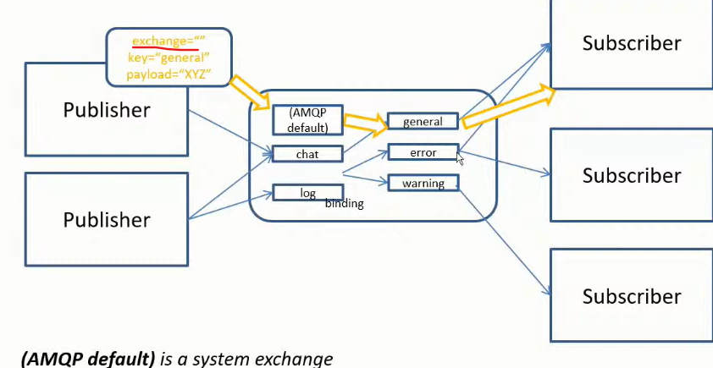

#### Direct exchange

* А direct exchange routes messages to a queue if the routing key of the message matches the binding key between the direct exchange and the queue
* Direct exchanges are suitable for point-to-point communication between endpoints
* Binding key should be defined here mandatory

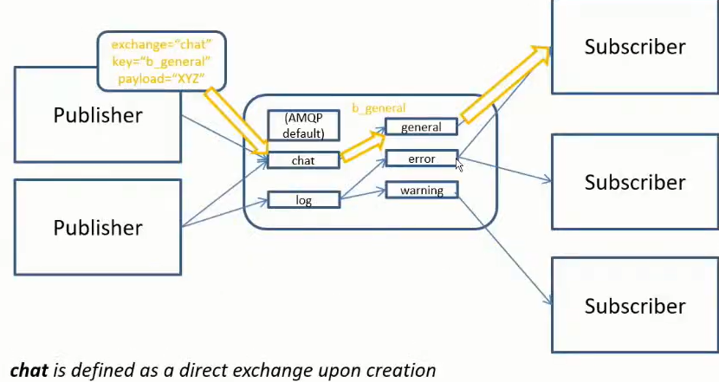

#### Fanout exchange

* А fanout exchange routes (broadcasts) messages to all queues that are bound to it (the binding key is not used)
* Fanout exchanges are suitable for publish-subscribe communication between endpoints

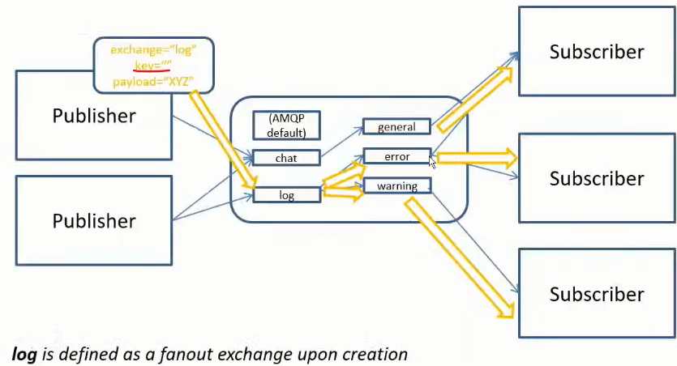

#### Topic exchange

* А topic exchange routes (multicasts) messages to all queues that have a binding key (can be a pattern) that matches the routing key of the message
* Topic exchanges are suitable for routing messages to different queues based on the type of message
* Диеса след *warning.* може да е всякаква дума

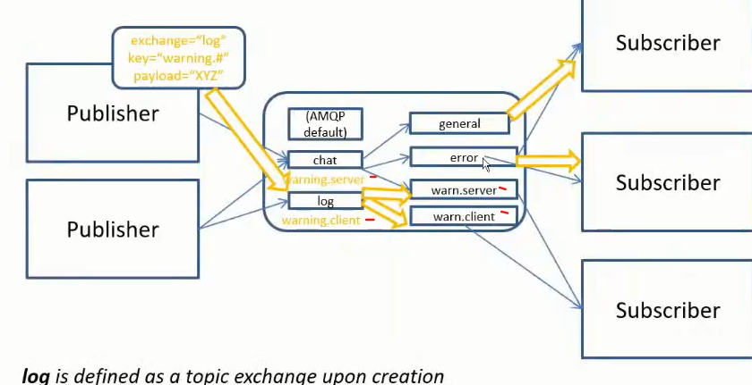

#### Headers exchange

* А headers exchange routes messages based on a custom message header
* Header exchanges are suitable for routing messages to different queues based on more than one attribute

### Installation of the RabbitMQ server

First install the Erlang - <https://www.erlang.org/downloads>

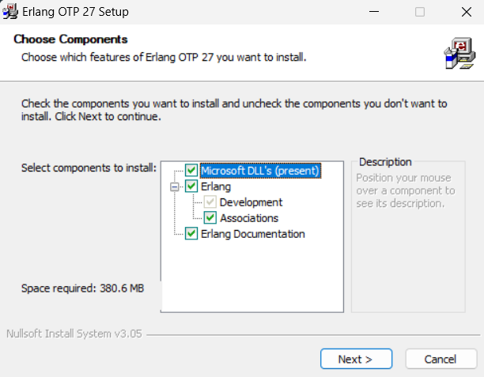

Then install the RabbitMQ server - <https://www.rabbitmq.com/docs/download>

rabbitmq-service.bat

rabbitmq-service.bat

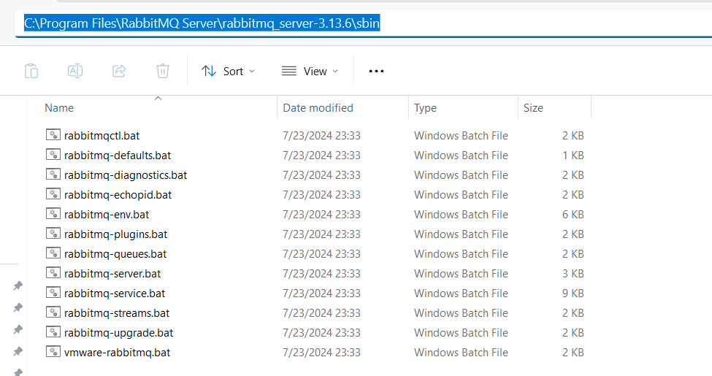

C:\Program Files\RabbitMQ Server\rabbitmq_server-3.13.6\sbin>**rabbitmq-plugins.bat enable** rabbitmq_management

Enabling plugins on node rabbit@SVILKATA:

rabbitmq_management

The following plugins have been configured:

  rabbitmq_management

  rabbitmq_management_agent

  rabbitmq_web_dispatch

Applying plugin configuration to rabbit@SVILKATA...

The following plugins have been enabled:

  rabbitmq_management

  rabbitmq_management_agent

  rabbitmq_web_dispatch

set 3 plugins.

Offline change; changes will take effect at broker restart.

**През CommandPrompt като администратор:**

C:\Program Files\RabbitMQ Server\rabbitmq_server-3.13.6\sbin>rabbitmq-plugins.bat list

Listing plugins with pattern ".*" ...

 Configured: E = explicitly enabled; e = implicitly enabled

 | Status: [failed to contact rabbit@SVILKATA - status not shown]

 |/

[  ] rabbitmq_amqp1_0              3.13.6

[  ] rabbitmq_auth_backend_cache   3.13.6

[  ] rabbitmq_auth_backend_http    3.13.6

[  ] rabbitmq_auth_backend_ldap    3.13.6

[  ] rabbitmq_auth_backend_oauth2  3.13.6

[  ] rabbitmq_auth_mechanism_ssl   3.13.6

[  ] rabbitmq_consistent_hash_exchange 3.13.6

[  ] rabbitmq_event_exchange       3.13.6

[  ] rabbitmq_federation           3.13.6

[  ] rabbitmq_federation_management 3.13.6

[  ] rabbitmq_jms_topic_exchange   3.13.6

**[*] rabbitmq_management           3.13.6**

**[*] rabbitmq_management_agent     3.13.6**

[  ] rabbitmq_mqtt                 3.13.6

[  ] rabbitmq_peer_discovery_aws   3.13.6

[  ] rabbitmq_peer_discovery_common 3.13.6

[  ] rabbitmq_peer_discovery_consul 3.13.6

[  ] rabbitmq_peer_discovery_etcd  3.13.6

[  ] rabbitmq_peer_discovery_k8s   3.13.6

[  ] rabbitmq_prometheus           3.13.6

[  ] rabbitmq_random_exchange      3.13.6

[  ] rabbitmq_recent_history_exchange  3.13.6

[  ] rabbitmq_sharding             3.13.6

[  ] rabbitmq_shovel               3.13.6

[  ] rabbitmq_shovel_management    3.13.6

[  ] rabbitmq_stomp                3.13.6

[  ] rabbitmq_stream               3.13.6

[  ] rabbitmq_stream_management    3.13.6

[  ] rabbitmq_top                  3.13.6

[  ] rabbitmq_tracing              3.13.6

[  ] rabbitmq_trust_store          3.13.6

**[*] rabbitmq_web_dispatch         3.13.6**

[  ] rabbitmq_web_mqtt             3.13.6

[  ] rabbitmq_web_mqtt_examples    3.13.6

[  ] rabbitmq_web_stomp            3.13.6

[  ] rabbitmq_web_stomp_examples   3.13.6

Type services.msc

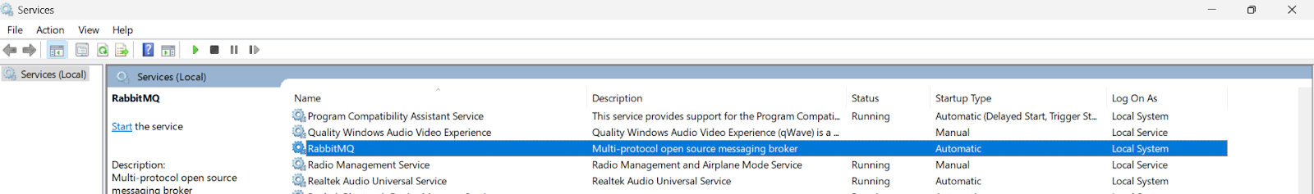

C:\Program Files\RabbitMQ Server\rabbitmq_server-3.13.6\sbin>**rabbitmq-server.bat**

2024-07-31 11:52:47.571000+03:00 [warning] <0.134.0> Using RABBITMQ_ADVANCED_CONFIG_FILE: c:/Users/svilk/AppData/Roaming/RabbitMQ/advanced.config

2024-07-31 11:52:52.145000+03:00 [notice] <0.45.0> Application syslog exited with reason: stopped

2024-07-31 11:52:52.145000+03:00 [notice] <0.213.0> Logging: switching to configured handler(s); following messages may not be visible in this log output

  ##  ##  RabbitMQ 3.13.6

  ##  ##

  ##########  Copyright (c) 2007-2024 Broadcom Inc and/or its subsidiaries

  ######  ##

  ##########  Licensed under the MPL 2.0. Website: https://rabbitmq.com

  Erlang:  27.0.1 [jit]

  TLS Library: OpenSSL - OpenSSL 3.1.0 14 Mar 2023

  Release series support status: see https://www.rabbitmq.com/release-information

  Doc guides:  https://www.rabbitmq.com/docs

  Support: https://www.rabbitmq.com/docs/contact

  Tutorials:   https://www.rabbitmq.com/tutorials

  Monitoring:  https://www.rabbitmq.com/docs/monitoring

  Upgrading:   https://www.rabbitmq.com/docs/upgrade

  Logs: <stdout>

     c:/Users/svilk/AppData/Roaming/RabbitMQ/log/rabbit@SVILKATA.log

  Config file(s): c:/Users/svilk/AppData/Roaming/RabbitMQ/advanced.config

  Starting broker... **completed with 3 plugins.**

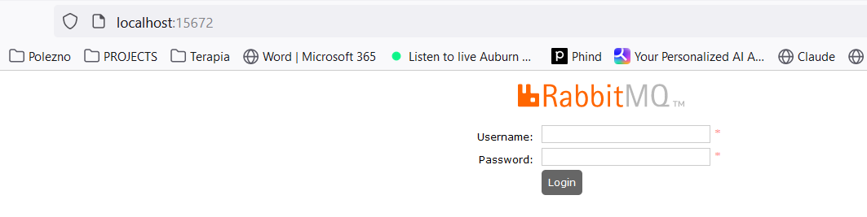

**username: guest**

**password: guest**

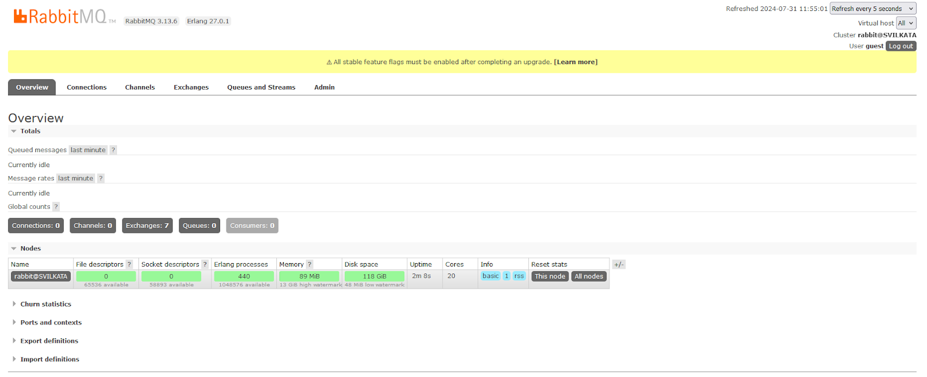

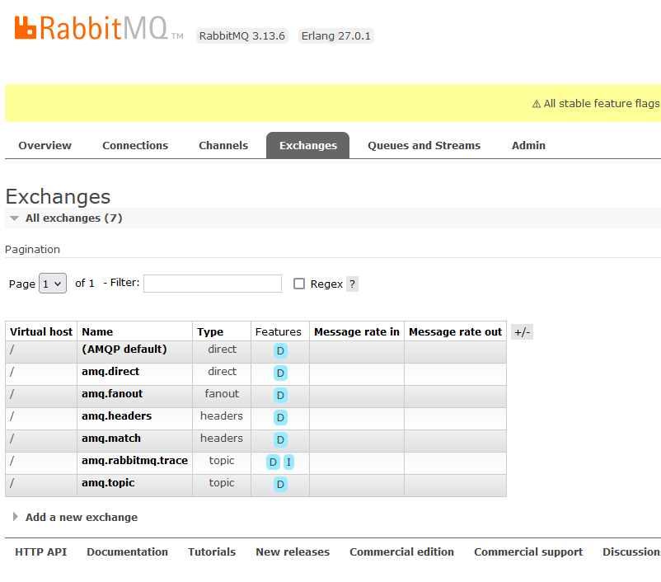

### Using the Java Client

<dependency>

 <groupId>com.rabbitmq</groupId>

 <artifactId>amqp-client</artifactId>

 <version>5.20.0</version>

</dependency>

import com.rabbitmq.client.Channel;

import com.rabbitmq.client.Connection;

import com.rabbitmq.client.ConnectionFactory;

import java.io.IOException;

import java.nio.charset.StandardCharsets;

import java.util.concurrent.TimeoutException;

public class Publisher {

   public static void main(String[] args) throws IOException, TimeoutException {

       Connection connection = null;

       Channel channel = null;

       try {

           ConnectionFactory connectionFactory = new ConnectionFactory();

           connectionFactory.setHost("localhost"); *//by default on port 15672*

connection = connectionFactory.newConnection();

           channel = connection.createChannel();

           channel.exchange**Declare**("name_exchange", "direct"); *//created only once on the RabbitMQ server*

channel.queue**Declare**("name_queue", false, false, false, null); *//created only once on the RabbitMQ server*

           channel.queueBind("name_queue", "name_exchange", "routing_key_test");

           channel.basicPublish("name_exchange", "routing_key_test", null,

                   "Hello RabbitMQ from Java client".getBytes(StandardCharsets.*UTF_8*));

       } finally {

           if (channel != null) {

               channel.close();

           }

           if (connection != null) {

               connection.close();

           }

       }

   }

}

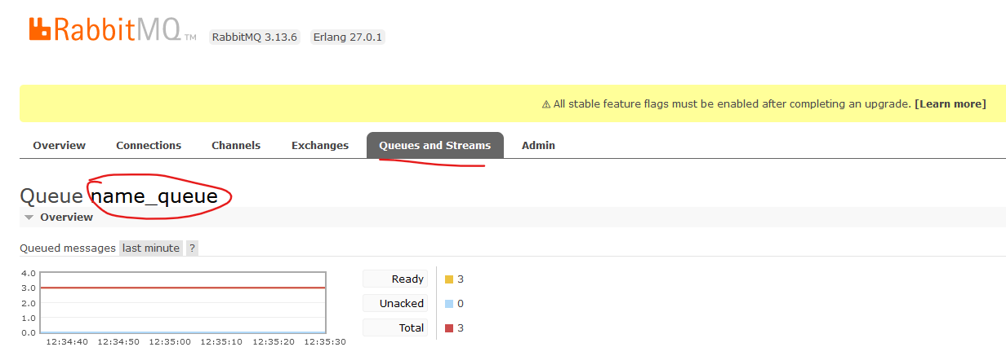

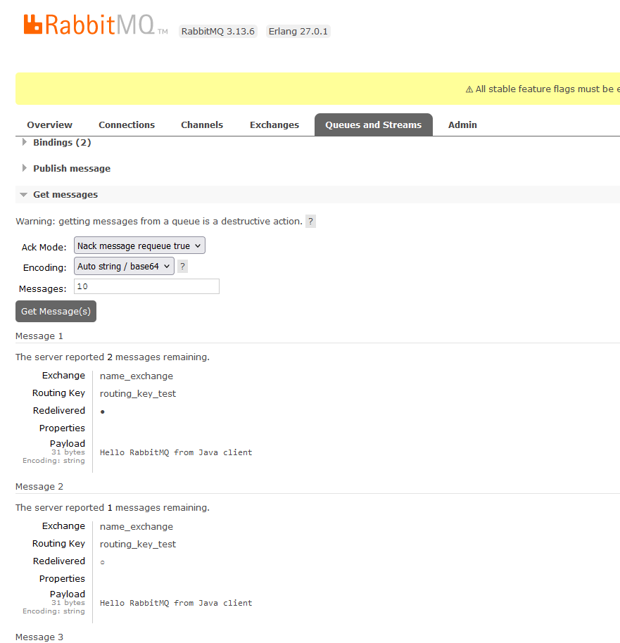

import com.rabbitmq.client.AMQP;

import com.rabbitmq.client.Channel;

import com.rabbitmq.client.Connection;

import com.rabbitmq.client.ConnectionFactory;

import com.rabbitmq.client.DefaultConsumer;

import com.rabbitmq.client.Envelope;

import java.io.IOException;

import java.util.concurrent.TimeoutException;

public class Subscriber {

   public static void main(String[] args) throws IOException, TimeoutException, InterruptedException {

       Connection connection = null;

       Channel channel = null;

       try {

           ConnectionFactory connectionFactory = new ConnectionFactory();

           connectionFactory.setHost("localhost"); *//by default on port 15672*

connection = connectionFactory.newConnection();

           channel = connection.createChannel();

           channel.exchangeDeclare("name_exchange", "direct"); *//created only once on the RabbitMQ server*

channel.queueDeclare("name_queue", false, false, false, null); *//created only once on the RabbitMQ server*

           channel.queueBind("name_queue", "name_exchange", "routing_key_test");

           while (true) {

               channel.basicConsume("name_queue", true, new DefaultConsumer(channel) {

                   @Override

                   public void handleDelivery(String consumerTag, Envelope envelope, AMQP.BasicProperties properties, byte[] body) throws IOException {

*// super.handleDelivery(consumerTag, envelope, properties, body);  no-op no work to do*

System.*out*.println(new String(body));

                   }

               });

               Thread.*sleep*(3000);

           }

       } finally {

           if (channel != null) {

               channel.close();

           }

           if (connection != null) {

               connection.close();

           }

       }

   }

}

### Administration

* Administration of the broker includes a number of activities such as:
  + Updating the broker
  + Backing up the broker database
  + installing/uninstalling and configuring plug-ins
  + Configuring the various components of the broker

* Apart from queues, exchanges and bindings we can also manage the following types of components:
  + vhosts (virtual hosts) - for logical separation of broker components
  + users
  + Parameters - defining upstream links to another brokers
  + Policies - for queue mirroring

* Administration of single instance or an entire cluster can be performed in several ways:
  + Using the management Web interface

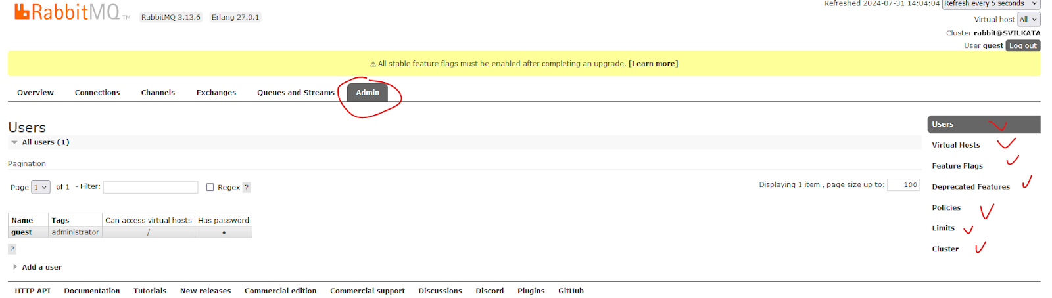

* Using the management HTTP API - rest API
* Using the **rabbitmq-admin.py / rabbitmqadmin.py** script - written on Python
* Using the **rabbitmqctl** utility

### Scalability and High Availability in RabbitMQ

#### Basic default configuration

* RabbitMQ provides clustering support that allows new RabbitMQ nodes to be added on the fly
* Clustering by default does not guarantee that message loss may or may not occur - ако дадена инстанция примерно падне

* Nodes in a RabbitMQ cluster can be:
  + DISK - data is persisted in the node database
  + RAM - data is buffered only in-memory - когато не е критично да се запазват данните след рестарт например
* **Nodes share only broker metadata - messages are not replicated among nodes!! - съобщението не се репликира в останалите node-ве**

**Example:**

А и B са DISK nodes, a C е Ram node.

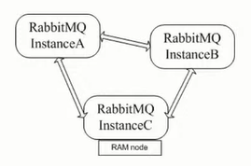

**Instance A node DISK**

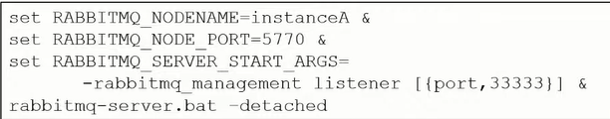

**Instance B node DISK**

Пускаме инстанция B, спираме я, присъединяваме я след това

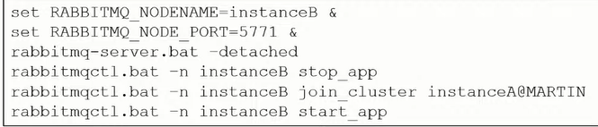

**Instance C node RAM**

Пускаме инстанция C, спираме я, присъединяваме я след това

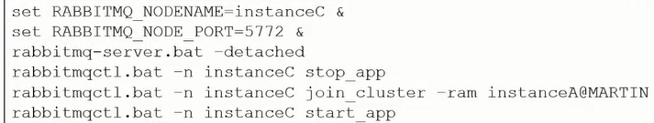

* If a node that hosts a queue buffers unprocessed messages goes down, then messages are lost
* Default clustering mechanism provides scalability in terms of queues rather than high availability

#### Mirrored queues

* **Mirrored queues** are an extension to the default clustering mechanism that can be used to establish **high availability** at the broker level
* Mirrored queues provide queue replication over different nodes that allows a message to survive node failure
* Queue mirroring is establishing by means of a mirroring policy that specifies:
  + Number of nodes to use for queue replication
  + Particular nodes designated by name for queue replication
  + All nodes for queue replication

* The node where the queue is created is the master node - all other nodes are slaves
* A new master node can be promoted in case the original one goes down
* A slave node is promoted to/as the new master in case it is fully synchronized with the old master

**Example:**

Let’s define the test queue in the cluster and mirror it over all other nodes:

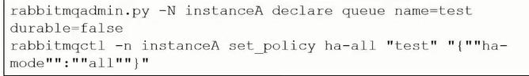

#### **Federation and Shovel plugins**

* The RabbitMQ clustering mechanism uses Erlang message passing along with a message cookie in order to establish communication between the nodes…….. which is **not reliable** over the Wide Area Networks!!
* In order to establish high availability among nodes in different geographic locations you can use the **federation, federation_management** and **shovel** plug-ins
* The shovel plug-in works at a lower level than the federation plug-in

##### **Federation**

* Ако искаме да репликираме опашката на отдалечена инстанция D:

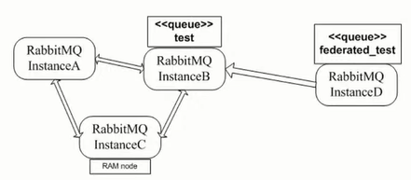

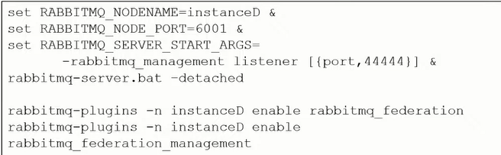

* Declare the **federated_test** queue



Declare the upstream to the initial cluster and set a federation link to the **test** queue:

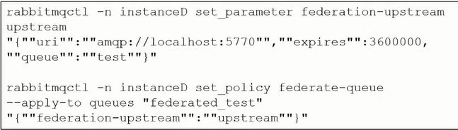

##### Shovel

The shovel plug-in provides two variants:

* **static** - all links between the source/destination nodes/clusters are defined statically in the RabbitMQ configuration file
* **dynamic** - all links between the source/destination nodes/clusters are defined dynamically via the RabbitMQ parameters

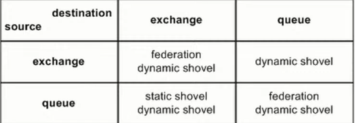

### Integrations

#### Info

* RabbitMQ provides integrations with other protocols such as STOMP, MQTT and LDAP by means of RabbitMQ plug-ins
* Using the Java Client - already discussed above
* The Spring framework provides integration with AMQP protocol and RabbitMQ in particular
* The **Spring AMQP framework** provides:
  + **RabbitAdmin** class for automatically declaring queues, exchanges and bindings
  + **Listener container** for asynchronous processing of inbound messages
  + **RabbitTemplate** class for sending and receiving messages

* Utilities of the Spring AMQP framework can be used directly in Java or preconfigured in the Spring configuration
* The **Spring Integration framework** to **Spring Boot** provides adapters for the AMQP protocol

* Integration with Quarkus framework

#### Spring AMQP framework

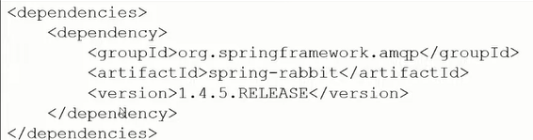

The **RabbitAdmin** class:

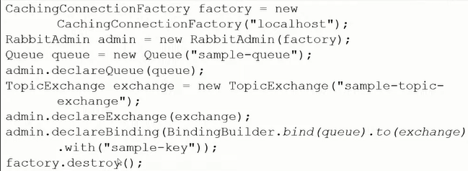

**Listener container**

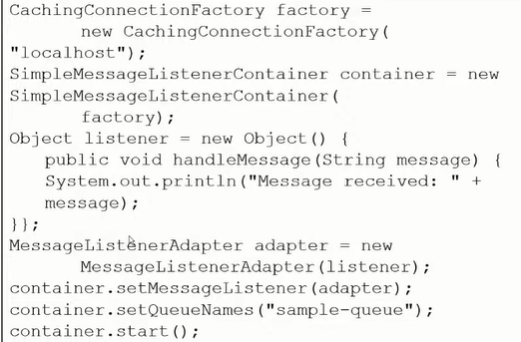

The **RabbitTemplate** class:

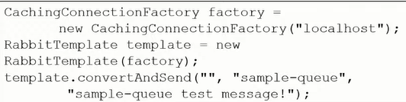

* All of the above Spring AMQP framework examples  can be configured using the Spring configuration - so that to be cleaner and to decouple RabbitMQ configuration from the business logic/Java code

For example within a **configuration.xml** file:

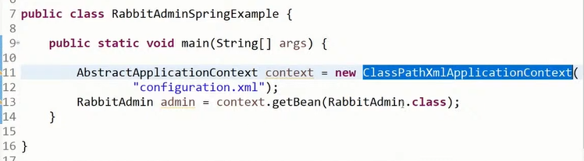

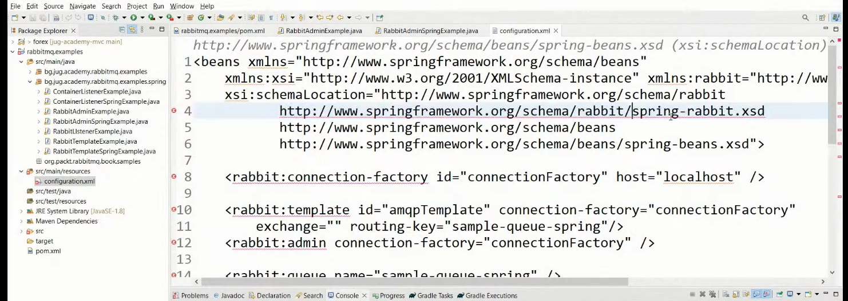

#### Spring Boot Starter AMQP - Spring Integration framework

In gradle

implementation ‘org.springframework.boot:**spring-boot-starter-amqp**’

Предоставя ни бийнове за  **RabbitAdmin** class, **Listener container** and **RabbitTemplate** class.

Посредством дефиниране на бийнове - можем да си декларираме **exchange, queue** или **queueBinding**

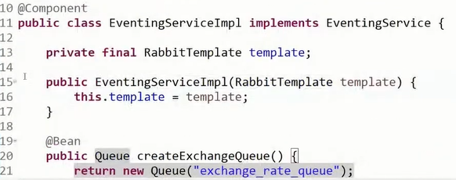

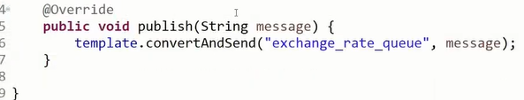

#### Quarkus framework

<dependency>

 <groupId>io.quarkus</groupId>

 <artifactId>quarkus-smallrye-reactive-messaging-rabbitmq</artifactId>

</dependency>

In application.properties file

mp.messaging.outgoing.bi.use-ssl=true

mp.messaging.outgoing.bi.connector=smallrye-rabbitmq

mp.messaging.outgoing.bi.exchange.type=direct

mp.messaging.outgoing.bi.port=5672

import io.smallrye.reactive.messaging.rabbitmq.**OutgoingRabbitMQMetadata**;

@Inject

@Channel("asd")  //from Microprofile

Emitter<String> emitter;  //from Microprofile

public void emmitMessage(RabbitMqPayload payload) {

   String messagePayload = JsonUtils.*toJsonString*(List.*of*(payload));

*LOGGER*.debugf("Emitting Bi message to RabbitMQ %s", messagePayload);

**OutgoingRabbitMQMetadata** metadata = new OutgoingRabbitMQMetadata.Builder()

**.withRoutingKey**(payload.routingKey())

           .build();

   Message<String> message = Message.of(messagePayload, Metadata.of(metadata));

   biEmitter.send(message); //from Microprofile

*LOGGER*.infof("Bi message emitted to route %s", payload.routingKey());

}

### Security

* RabbitMQ uses SASL Simple Authentication Security Layer for authentication (SASL PLAIN used by default)
* RabbitMQ uses access control lists (permissions) for authorization
* SSL/TLS support can be enabled for the AMQP communication channels
* SSL/TLS support can be enabled for node communication between nodes in a cluster
* SSL/TLS support can be enabled for the federation and shovel plug-ins

## II. Apache Kafka

Book

Kafka – The Definitive Guide – Real-Time Data and Stream Processing at Scale

### Use cases

* For activity tracking – например LinkedIn да знае кой профил гледате/се гледа най-много
* Messaging
* Metrics and logging
* Commit log
* Stream processing – data pipeline – за един ден колко човека са кликнали на моята страница

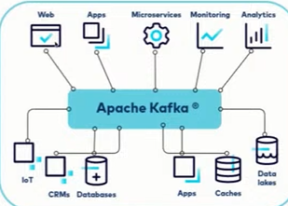

### Brokers and Clusters

A single Kafka server/instance is called a ***broker***. The broker receives messages from producers, assigns offsets to them, and writes the messages to storage on disk. It also services consumers, responding to fetch requests for partitions and responding with the messages that have been published. Depending on the specific hardware and its performance characteristics, a single broker can easily handle thousands and millions of messages per second.

В един Kafka инстанция може да има 1 или повече топици, а във всеки топик има определен брой partitions.

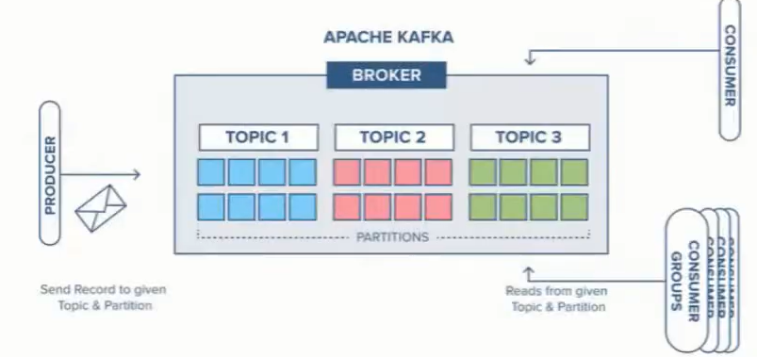

**Cluster** – комбинация от няколко брокера (поне 3), т.е. няколко брокера които работят заедно и се координират заедно.

С други думи да има Fault tolerance, и когато един broker instance падне/или целият cluster падне, то да има опция да се репликират данните.

Като си правим cluster, то самите broker instances да бъдат географски на различни места – че ако падне нета на единия instance, дa не паднат всичките брокер инстанции и дефакто целия клъстер.

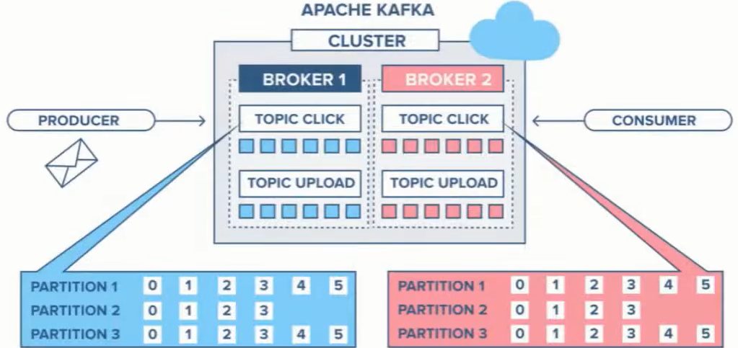

### Topics and Partitions

* With key – Messages are appended in the same partition if they have the same key
* Without key – messages are appended to the next partition in a round-robin fashion
* The order is guaranteed only in a partition and only if we have/use **key**

**Kafka topic – основната единица**

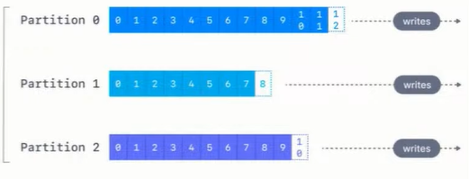

Колкото partitions има в даден топик, то толкова паралелни consumers може да имаме.

Ако имаме повече от 1 partition в даден топик, то нямаме гаранция за подредба. Освен разбира се ако не използваме **key!**

Partition представлява множество съобщения/елементи едно след друго, с определен индекс който наричаме **offset!**

### Topic replication

* **min.insync.replicas** – how many brokers (including the leader) should have the data before it is considered stored and ready to serve. Recommended is **replication.factor -1** (можем да настроим да я има тази информация на само 1 брокер, на още 2 брокера, и т.н. – зависи от use case-a и от наличните брокери)

Each partition is replicated separately, has its own broker leader and ISR.

Обикновено единия брокер се води Leader на partition-a.

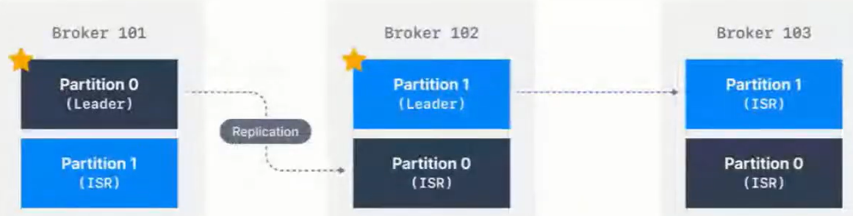

Когато изпращаме данни, ние изпращаме данни към съответния Leader на съответния partition.

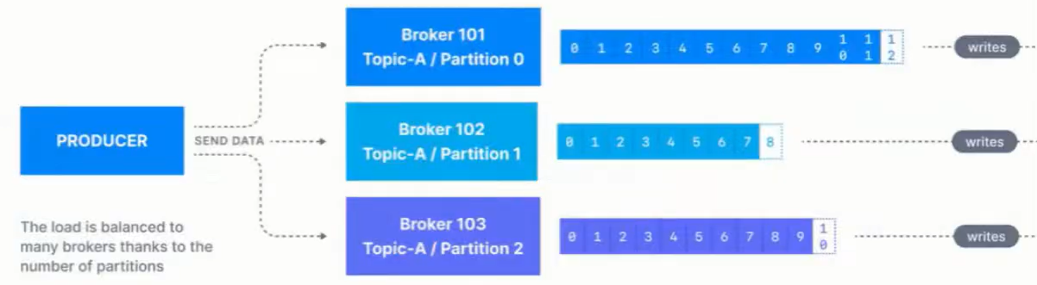

### What is a Kafka message

И key и value са **binary**! За Кафка всичко е byte-ове.

Възможност за компресия. Запазват се sequential – на следващия сегмент на диска.

Headers – например информация през кои сървиси е минало

Информация на кой partition e, и на кой офсет индекс е даденото съобщение.

Timestamp by default се слага от producer-a, а не вътрешно от Кафка брокера!

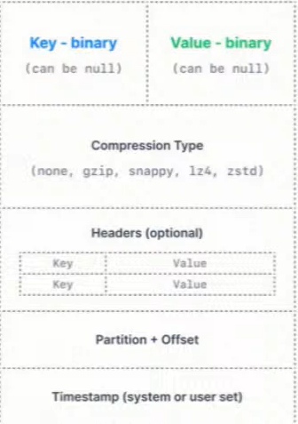

### Consumers

Kafka скалира не на базата на топици, а на базата на partitions!!!

#### Consumer group

Пример: Имаме 5 партишъни. И разпределяме партишъните на различни consumers.

В текущият пример можем да сложим общо макс 5 consumers!!! Или с други думи правилото е че можем да скалираме consumers до броя на partitions!

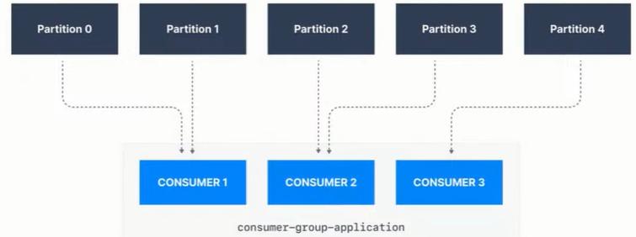

#### Many consumers groups

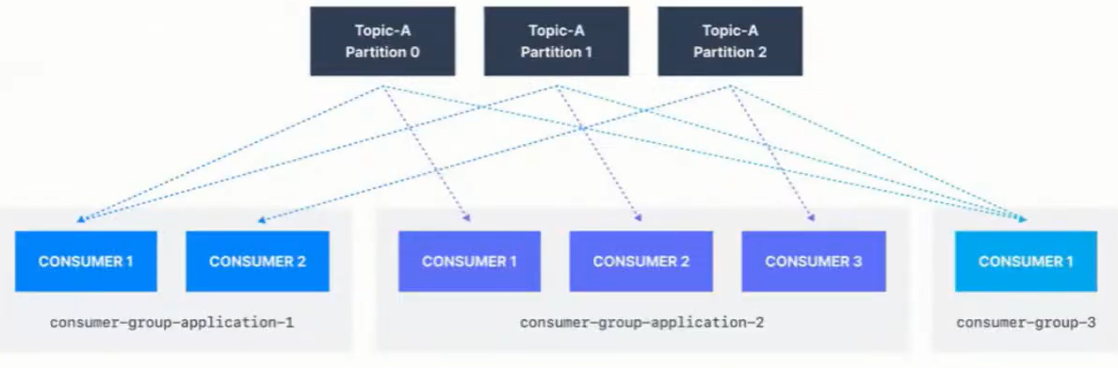

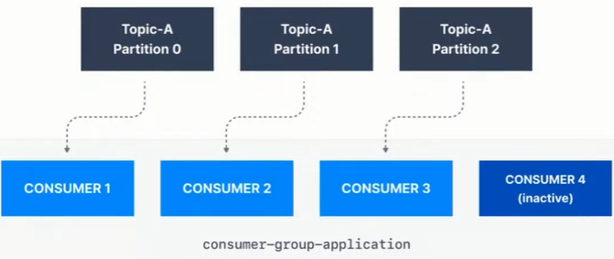

#### Commit

* Commit is the process of telling Kafka to remember that you have processed **(both produced and consumed)** the messages of a partition to a specific offset
* When first started, the consumer looks up where it left off via the kafka commit facility
* A call to **seek()** is made to initialize an internal counter which determines the messages that will be poll()-ed for the lifetime of the **consumer**

**Poll** означава вземи съобщението от брокера, и го процесни при теб (при Spring framework-a например)

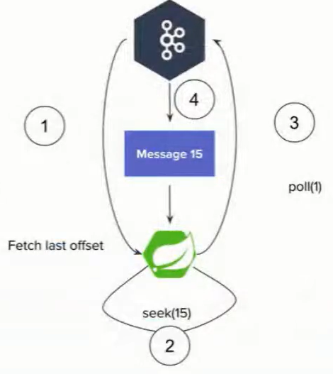

#### Producer

**Batching**

**spring.kafka.producer.batch-size=100**

Sets the maximum number of records to be sent om one request. Sends the batch as soon as it is filled.

**spring.kafka.producer.properties[linger.ms]**

Gives the batch that much ms to be filled and sent automatically (see above). After the duration, if the batch is still not filled, sends it as it is.

**spring.kafka.producer.buffer-memory**

If a batch cannot be sent due to broker being down or whatever other recoverable issue, fills new batches in the buffer.

After the buffer is filled, the **send()** method blocks for **spring.kafka.producer.properties[max.block.ms]**. This buffer **must be large enough** to contain at least one full batch or such batches will be lost.

**spring.kafka.producer.compression-type=lz4** avro gzip snappy

The batch will be compressed before sending. This directly increases throughput and latency (not much latency)

Следните неща ни интересуват като изпращаме съобщения:

* **acks=0**

Does not wait for a response to consider the sent successful



* **acks=1**

Wait for the leader to commit the message/s but do not wait for the replicas to commit!!

Изчакай поне Leader да ти върне, че е записано съобщението, но не чакаме да се случи репликацията. Проблем би бил ако leader-а умре/падне, и тогава съобщението се губи



* **acks=all**

Wait for the leader and all replicas(или еди колко си на брой реплики) to commit, so that to consider the message/s sent.

Note: all == -1

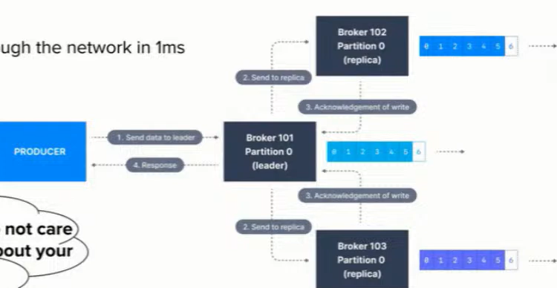

x2 slower – докато се получат повтържденията за репликите, и се забавя

Assuming that a message/s is sent through the network in 1ms. This leads to 2.5ms latency.

1000 / 2ms = 2micro s per message

#### Consumer

**Batching again**

**spring.kafka.consumer.max-poll-records=500**

Sets the maximum number of records that will be returned by a poll()

**spring.kafka.listener.ack-mode=batch**

Auto commit is mostly evil. Don’t use it by default unless actually verifiably ok for your data

Като процеснеш batch-а, то commit-ни ръчно тогава offset-а. Ако се закача наново, то да не го процесна същото съобщение.

**spring.kafka.consumer.enable-auto-commit=false**

**max.poll.interval.ms=5min**

You must be able to process a full batch in that time or a rebalance will be triggered. На колко време да вземаме съобщенията обратно.

### Delivery guarantees

Това съобщение защо сме го процеснали 2 пъти.

Или това съобщение защо изобщо не сме го процеснали.

At **least once** means not that a single message might be duplicated but a whole batch it is scary with big batches 😊

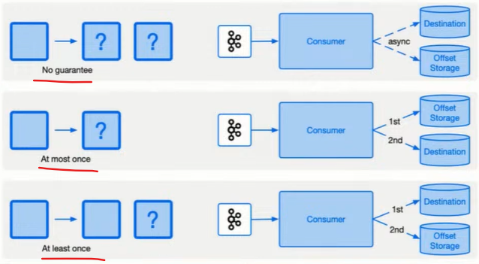

Idempotent producer – получаване на дуплицирани съобщения

Поради network проблем може Кафка брокера да е приел съобщението и да не отговори, и ние да изпратим съобщението наново.

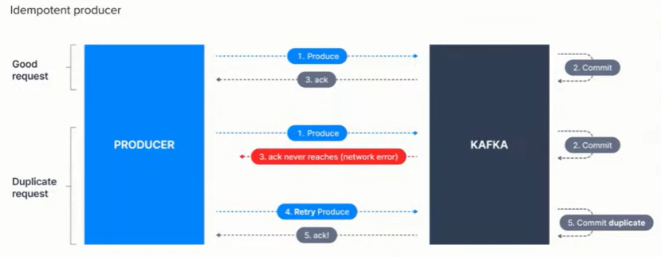

Idempotent producer

**spring.kafka.producer.properties[max.in.flight.requests.per.connection]=5**

**spring.kafka.producer.properties[enable.idempotence]=true**

It works for the lifespan of the producer. Required but not enough for proper idempotency across restarts.

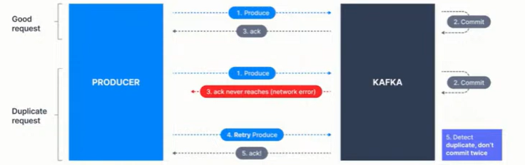

Ако е Network проблем, това решава дуплицирането.

Consumer – producer problem

Ако чета в Кафка, и пиша в Кафка – имам проблем. Защото трябва да имаме/използваме нещо, което се казва трансакции (трансакции в Кафка).

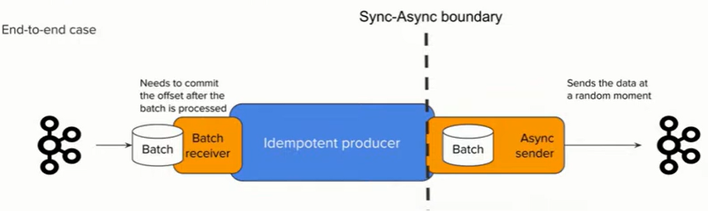

**kafkaTemplate.send(msg)**

This is fully async. You don’t know when the data is actually going to be sent. The method returns a future that can be waited but to do it for each message breaks the batching and is extremely slow.

### Demo with kafka-clients

Docker-compose file for Zookeeper, Kafka and RedPanda

and also logback.xml configuration. – see BGJUG public repo.

**build.gradle – Groovy style**

dependencies **{** implementation group: 'org.apache.kafka', name: **'kafka-clients'**, version: '3.6.1'  
 *//SLF4J Api* implementation 'org.slf4j:slf4j-api:1.7.32' *//Use the latest version available  
  
 //Logback (SLF$J implementation)* implementation 'ch.qos.logback:logback-classic:1.2.6' *//Use the latest version available*  
**}**

import org.apache.kafka.clients.producer.**KafkaProducer**;  
import org.apache.kafka.clients.producer.Producer;  
import org.apache.kafka.clients.producer.ProducerRecord;  
  
import java.util.Properties;  
  
public class ProducerExample {  
 public static void main(String[] args) {  
 Properties properties = new Properties();  
 properties.put("bootstrap.servers", "localhost:29092");  
 properties.put("key.serializer", "org.apache.kafka.common.serialization.StringSerializer");  
 properties.put("value.serializer", "org.apache.kafka.common.serialization.StringSerializer");  
  
 Producer<String, String> producer = new KafkaProducer<>(properties);  
  
 producer.send(new ProducerRecord<>("bgjug","KAFKA","Welcome to RabbitMQ"), (metadata, exception) -> {  
 if (exception == null) {  
 System.*out*.println("Message sent successfully - Topic: " +  
 metadata.topic() + ", Partition: " + metadata.partition() +  
 ", Offset: " + metadata.offset());  
 } else {  
 System.*err*.println("Error sending message: " + exception.getMessage());  
 }  
 });  
  
 producer.close();  
 }  
}

След като пуснем Producer-a, получаваме следния лог:

13:19:15.064 [main] INFO o.a.k.c.producer.ProducerConfig - ProducerConfig values:

**acks = -1**

auto.include.jmx.reporter = true

batch.size = 16384

bootstrap.servers = [localhost:29092]

buffer.memory = 33554432

client.dns.lookup = use_all_dns_ips

client.id = producer-1

compression.type = none

**connections.max.idle.ms = 540000**

delivery.timeout.ms = 120000

enable.idempotence = true

interceptor.classes = []

**key.serializer = class org.apache.kafka.common.serialization.StringSerializer**

linger.ms = 0

max.block.ms = 60000

max.in.flight.requests.per.connection = 5

max.request.size = 1048576

metadata.max.age.ms = 300000

metadata.max.idle.ms = 300000

metric.reporters = []

metrics.num.samples = 2

metrics.recording.level = INFO

metrics.sample.window.ms = 30000

partitioner.adaptive.partitioning.enable = true

partitioner.availability.timeout.ms = 0

partitioner.class = null

partitioner.ignore.keys = false

receive.buffer.bytes = 32768

reconnect.backoff.max.ms = 1000

reconnect.backoff.ms = 50

request.timeout.ms = 30000

retries = 2147483647

retry.backoff.ms = 100

sasl.client.callback.handler.class = null

sasl.jaas.config = null

sasl.kerberos.kinit.cmd = /usr/bin/kinit

sasl.kerberos.min.time.before.relogin = 60000

sasl.kerberos.service.name = null

sasl.kerberos.ticket.renew.jitter = 0.05

sasl.kerberos.ticket.renew.window.factor = 0.8

sasl.login.callback.handler.class = null

sasl.login.class = null

sasl.login.connect.timeout.ms = null

sasl.login.read.timeout.ms = null

sasl.login.refresh.buffer.seconds = 300

sasl.login.refresh.min.period.seconds = 60

sasl.login.refresh.window.factor = 0.8

sasl.login.refresh.window.jitter = 0.05

sasl.login.retry.backoff.max.ms = 10000

sasl.login.retry.backoff.ms = 100

sasl.mechanism = GSSAPI

sasl.oauthbearer.clock.skew.seconds = 30

sasl.oauthbearer.expected.audience = null

sasl.oauthbearer.expected.issuer = null

sasl.oauthbearer.jwks.endpoint.refresh.ms = 3600000

sasl.oauthbearer.jwks.endpoint.retry.backoff.max.ms = 10000

sasl.oauthbearer.jwks.endpoint.retry.backoff.ms = 100

sasl.oauthbearer.jwks.endpoint.url = null

sasl.oauthbearer.scope.claim.name = scope

sasl.oauthbearer.sub.claim.name = sub

sasl.oauthbearer.token.endpoint.url = null

security.protocol = PLAINTEXT

security.providers = null

send.buffer.bytes = 131072

socket.connection.setup.timeout.max.ms = 30000

socket.connection.setup.timeout.ms = 10000

ssl.cipher.suites = null

ssl.enabled.protocols = [TLSv1.2, TLSv1.3]

ssl.endpoint.identification.algorithm = https

ssl.engine.factory.class = null

ssl.key.password = null

ssl.keymanager.algorithm = SunX509

ssl.keystore.certificate.chain = null

ssl.keystore.key = null

ssl.keystore.location = null

ssl.keystore.password = null

ssl.keystore.type = JKS

ssl.protocol = TLSv1.3

ssl.provider = null

ssl.secure.random.implementation = null

ssl.trustmanager.algorithm = PKIX

ssl.truststore.certificates = null

ssl.truststore.location = null

ssl.truststore.password = null

ssl.truststore.type = JKS

transaction.timeout.ms = 60000

transactional.id = null

value.serializer = class org.apache.kafka.common.serialization.StringSerializer

import **org.apache.kafka.clients.consumer**.Consumer;  
import org.apache.kafka.clients.consumer.ConsumerConfig;  
import org.apache.kafka.clients.consumer.ConsumerRecords;  
import org.apache.kafka.clients.consumer.KafkaConsumer;  
import org.apache.kafka.common.serialization.StringDeserializer;  
import org.slf4j.Logger;  
import org.slf4j.LoggerFactory;  
  
import java.time.Duration;  
import java.util.Collections;  
import java.util.Properties;  
  
public class ConsumerExample {  
  
 private static final Logger *logger* = LoggerFactory.*getLogger*(ConsumerExample.class);  
  
 public static void main(String[] args) {  
 Properties properties = new Properties();  
 properties.put(ConsumerConfig.*BOOTSTRAP_SERVERS_CONFIG*, "localhost:29092");  
*// properties.put(ConsumerConfig.GROUP_ID_CONFIG, "your.group.id");* properties.put(ConsumerConfig.*GROUP_ID_CONFIG*, "svilen");  
 properties.put(ConsumerConfig.*KEY_DESERIALIZER_CLASS_CONFIG*, StringDeserializer.class.getName());  
 properties.put(ConsumerConfig.*VALUE_DESERIALIZER_CLASS_CONFIG*, StringDeserializer.class.getName());  
 properties.put(ConsumerConfig.*AUTO_OFFSET_RESET_CONFIG*, "earliest");  
  
 Consumer<String, String> consumer = new KafkaConsumer<>(properties);  
 consumer.subscribe(Collections.*singletonList*("bgjug"));  
  
 while (true) {  
 ConsumerRecords<String, String> records = consumer.poll(Duration.*ofMillis*(100));  
  
 records.forEach( record -> {  
 *logger*.info("Consumed message - Topic: {}, Partition: {}, Offset: {}, Key: {}, Value: {}",  
 record.topic(), record.partition(), record.offset(), record.key(), record.value());  
 });  
 }  
   
 }  
}

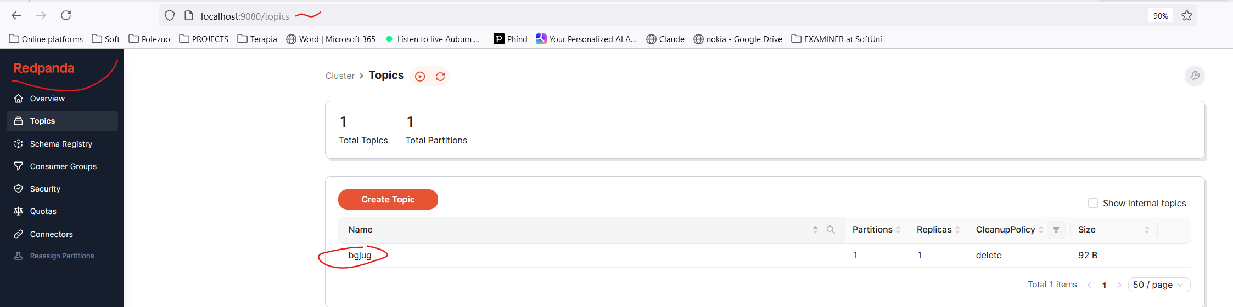

### Demo with Spring

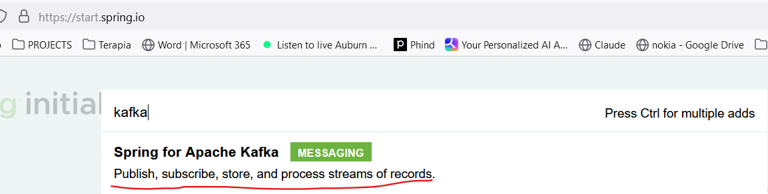

dependencies **{** implementation 'org.springframework.boot:spring-boot-starter-web'  
 implementation **'org.springframework.kafka:spring-kafka'**  
  
 testImplementation 'org.springframework.boot:spring-boot-starter-test'  
 testImplementation **'org.springframework.kafka:spring-kafka-test'**  
 testRuntimeOnly 'org.junit.platform:junit-platform-launcher'  
**}**

<https://spring.io/projects/spring-kafka>

<https://spring.io/projects/spring-kafka#learn>

<https://docs.spring.io/spring-kafka/reference/index.html>

<https://docs.spring.io/spring-kafka/reference/kafka/receiving-messages/listener-annotation.html>

<https://docs.spring.io/spring-kafka/reference/kafka/sending-messages.html>

Не е добре на production Кафка сама да си прави топиците – тази опция трябва да бъде настроена подходящо!!!

2024-08-12T13:36:36.054+03:00 INFO 9752 --- [live-demo] [ main] o.a.k.clients.consumer.ConsumerConfig : ConsumerConfig values:

allow.auto.create.topics = true

auto.commit.interval.ms = 5000

auto.include.jmx.reporter = true

auto.offset.reset = earliest

bootstrap.servers = [localhost:29092]

check.crcs = true

client.dns.lookup = use_all_dns_ips

client.id = consumer-application-3

client.rack =

connections.max.idle.ms = 540000

default.api.timeout.ms = 60000

enable.auto.commit = false

exclude.internal.topics = true

fetch.max.bytes = 52428800

fetch.max.wait.ms = 500

fetch.min.bytes = 1

group.id = application

group.instance.id = null

heartbeat.interval.ms = 3000

interceptor.classes = []

internal.leave.group.on.close = true

internal.throw.on.fetch.stable.offset.unsupported = false

isolation.level = read_uncommitted

key.deserializer = class org.apache.kafka.common.serialization.StringDeserializer

max.partition.fetch.bytes = 1048576

max.poll.interval.ms = 300000

max.poll.records = 500

metadata.max.age.ms = 300000

metric.reporters = []

metrics.num.samples = 2

metrics.recording.level = INFO

metrics.sample.window.ms = 30000

partition.assignment.strategy = [class org.apache.kafka.clients.consumer.RangeAssignor, class org.apache.kafka.clients.consumer.CooperativeStickyAssignor]

receive.buffer.bytes = 65536

reconnect.backoff.max.ms = 1000

reconnect.backoff.ms = 50

request.timeout.ms = 30000

retry.backoff.ms = 100

sasl.client.callback.handler.class = null

sasl.jaas.config = null

sasl.kerberos.kinit.cmd = /usr/bin/kinit

sasl.kerberos.min.time.before.relogin = 60000

sasl.kerberos.service.name = null

sasl.kerberos.ticket.renew.jitter = 0.05

sasl.kerberos.ticket.renew.window.factor = 0.8

sasl.login.callback.handler.class = null

sasl.login.class = null

sasl.login.connect.timeout.ms = null

sasl.login.read.timeout.ms = null

sasl.login.refresh.buffer.seconds = 300

sasl.login.refresh.min.period.seconds = 60

sasl.login.refresh.window.factor = 0.8

sasl.login.refresh.window.jitter = 0.05

sasl.login.retry.backoff.max.ms = 10000

sasl.login.retry.backoff.ms = 100

sasl.mechanism = GSSAPI

sasl.oauthbearer.clock.skew.seconds = 30

sasl.oauthbearer.expected.audience = null

sasl.oauthbearer.expected.issuer = null

sasl.oauthbearer.jwks.endpoint.refresh.ms = 3600000

sasl.oauthbearer.jwks.endpoint.retry.backoff.max.ms = 10000

sasl.oauthbearer.jwks.endpoint.retry.backoff.ms = 100

sasl.oauthbearer.jwks.endpoint.url = null

sasl.oauthbearer.scope.claim.name = scope

sasl.oauthbearer.sub.claim.name = sub

sasl.oauthbearer.token.endpoint.url = null

security.protocol = PLAINTEXT

security.providers = null

send.buffer.bytes = 131072

session.timeout.ms = 45000

socket.connection.setup.timeout.max.ms = 30000

socket.connection.setup.timeout.ms = 10000

ssl.cipher.suites = null

ssl.enabled.protocols = [TLSv1.2, TLSv1.3]

ssl.endpoint.identification.algorithm = https

ssl.engine.factory.class = null

ssl.key.password = null

ssl.keymanager.algorithm = SunX509

ssl.keystore.certificate.chain = null

ssl.keystore.key = null

ssl.keystore.location = null

ssl.keystore.password = null

ssl.keystore.type = JKS

ssl.protocol = TLSv1.3

ssl.provider = null

ssl.secure.random.implementation = null

ssl.trustmanager.algorithm = PKIX

ssl.truststore.certificates = null

ssl.truststore.location = null

ssl.truststore.password = null

ssl.truststore.type = JKS

value.deserializer = class org.apache.kafka.common.serialization.StringDeserializer

import lombok.RequiredArgsConstructor;  
import org.springframework.boot.CommandLineRunner;  
import org.springframework.boot.SpringApplication;  
import org.springframework.boot.autoconfigure.SpringBootApplication;  
import org.springframework.kafka.config.KafkaListenerEndpointRegistry;  
import org.springframework.kafka.core.KafkaTemplate;  
  
@SpringBootApplication  
@RequiredArgsConstructor  
public class LiveDemoApplication implements CommandLineRunner {  
  
 private final KafkaTemplate<String, String> kafkaTemplate; *//injecting it* private final KafkaListenerEndpointRegistry kafkaListenerEndpointRegistry; *//injecting it* public static void main(String[] args) {  
 SpringApplication.*run*(LiveDemoApplication.class, args);  
 }  
  
 @Override  
 public void run(String... args) throws Exception {  
*// for (int i = 0; i < 25_000_000; i++) {  
// kafkaTemplate.send("welcometokafka", "When is next Java beer in Plovdiv?");  
// }* kafkaListenerEndpointRegistry.getListenerContainer("bgjug").start(); //How to dynamically start/stop Kafka Listener  
 }  
}

--------------------

import lombok.extern.slf4j.Slf4j;  
import org.springframework.kafka.annotation.KafkaListener;  
import org.springframework.stereotype.Component;  
  
@Slf4j  
@Component  
public class KafkaConsumer {  
  
*// @KafkaListener(topics = "welcometokafka", groupId = "application", concurrency = "3")  
// @KafkaListener(topics = "welcometokafka", groupId = "application")* @KafkaListener(id = "bgjug", topics = "welcometokafka", groupId = "application", autoStartup = "false")  
 public void listen(String data) {  
 *log*.info(data);  
 }  
}

---------------------------

import org.apache.kafka.clients.consumer.ConsumerConfig;  
import org.apache.kafka.common.serialization.StringDeserializer;  
import org.springframework.context.annotation.Bean;  
import org.springframework.context.annotation.Configuration;  
import org.springframework.kafka.config.ConcurrentKafkaListenerContainerFactory;  
import org.springframework.kafka.core.ConsumerFactory;  
import org.springframework.kafka.core.DefaultKafkaConsumerFactory;  
  
import java.util.HashMap;  
import java.util.Map;  
  
@Configuration  
public class KafkaConsumerConfig {  
  
 @Bean  
 public ConsumerFactory<String, String> consumerFactory() {  
 return new DefaultKafkaConsumerFactory<>(consumerConfigs());  
 }  
  
 @Bean  
 public Map<String, Object> consumerConfigs() {  
 Map<String, Object> props = new HashMap<>();  
 props.put(ConsumerConfig.*BOOTSTRAP_SERVERS_CONFIG*, "localhost:29092");  
 props.put(ConsumerConfig.*KEY_DESERIALIZER_CLASS_CONFIG*, StringDeserializer.class);  
 props.put(ConsumerConfig.*VALUE_DESERIALIZER_CLASS_CONFIG*, StringDeserializer.class);  
  
 props.put(ConsumerConfig.*AUTO_OFFSET_RESET_CONFIG*, "earliest"); *//when app goes down and then restart* props.put(ConsumerConfig.*MAX_POLL_INTERVAL_MS_CONFIG*, 1); *//* props.put(ConsumerConfig.*MAX_POLL_RECORDS_CONFIG*, 100_000); *//* return props;  
 }  
  
 @Bean  
 ConcurrentKafkaListenerContainerFactory<String, String> kafkaListenerContainerFactory(ConsumerFactory<String, String> consumerFactory) {  
 ConcurrentKafkaListenerContainerFactory<String, String> factory = new ConcurrentKafkaListenerContainerFactory<>();  
 factory.setConsumerFactory(consumerFactory);  
  
 return factory;  
 }  
}

--------------------

import org.apache.kafka.clients.producer.ProducerConfig;  
import org.apache.kafka.common.serialization.StringSerializer;  
import org.springframework.context.annotation.Bean;  
import org.springframework.context.annotation.Configuration;  
import org.springframework.kafka.core.DefaultKafkaProducerFactory;  
import org.springframework.kafka.core.KafkaTemplate;  
import org.springframework.kafka.core.ProducerFactory;  
  
import java.util.HashMap;  
import java.util.Map;  
  
@Configuration  
public class KafkaProducerConfig {  
 @Bean  
 public KafkaTemplate<String, String> kafkaTemplate(ProducerFactory<String, String> producerFactory) { *//Injecting the producer factory* return new KafkaTemplate<String, String>(producerFactory);  
 }  
  
 @Bean  
 public ProducerFactory<String, String> producerFactory() {  
 return new DefaultKafkaProducerFactory<>(producerConfigs());  
 }  
  
 @Bean  
 public Map<String, Object> producerConfigs() {  
 Map<String, Object> props = new HashMap<>();  
 props.put(ProducerConfig.*BOOTSTRAP_SERVERS_CONFIG*, "localhost:29092");  
 props.put(ProducerConfig.*KEY_SERIALIZER_CLASS_CONFIG*, StringSerializer.class);  
 props.put(ProducerConfig.*VALUE_SERIALIZER_CLASS_CONFIG*, StringSerializer.class);  
 props.put(ProducerConfig.*COMPRESSION_TYPE_CONFIG*, "gzip");  
 *// See https://kafka.apache.org/documentation/#producerconfigs for more properties* return props;  
 }  
}

### Quarkus integration

<dependency>  
 <groupId>io.quarkus</groupId>  
 <artifactId>quarkus-smallrye-reactive-messaging-kafka</artifactId>  
</dependency>

------------

application.properties

*#########################  
## Logging configuration  
#########################*

quarkus.log.category."io.zerodt.service.KafkaEventLogProducer".level=INFO  
%dev.quarkus.log.category."io.zerodt.service.KafkaEventLogProducer".level=DEBUG  
%dev.quarkus.log.category."org.apache.kafka.clients".level=ERROR

*#########################  
## Kafka configuration  
#########################*%dev.kafka.bootstrap.servers=localhost:9092  
%prod.kafka.sasl.jaas.config=org.apache.kafka.common.security.scram.ScramLoginModule required username="${KAFKA_USER}" password="${KAFKA_PASSWORD}";  
  
mp.messaging.incoming.analytics-in.connector=smallrye-kafka  
mp.messaging.incoming.analytics-in.topic=analytics  
mp.messaging.incoming.analytics-in.key.serializer=org.apache.kafka.common.serialization.StringSerializer  
mp.messaging.incoming.analytics-in.value.serializer=org.apache.kafka.common.serialization.StringSerializer  
mp.messaging.incoming.analytics-in.group.id=wallet-service  
  
mp.messaging.outgoing.analytics.connector=smallrye-kafka  
mp.messaging.outgoing.analytics.topic=analytics  
mp.messaging.outgoing.analytics.key.serializer=org.apache.kafka.common.serialization.StringSerializer  
mp.messaging.outgoing.analytics.value.serializer=org.apache.kafka.common.serialization.StringSerializer

----------------------------

import io.smallrye.reactive.messaging.annotations.Blocking;  
import **io.smallrye.reactive.messaging.kafka.KafkaRecord**;  
import io.zerodt.bonus.dto.CancelBonusDTO;  
import io.zerodt.dto.AccountStatusChangedDTO;  
import io.zerodt.dto.UserProfileDTO;  
import io.zerodt.exception.BadDataException;  
import io.zerodt.service.WalletService;  
import io.zerodt.util.ExcludeCodeCoverageGenerated;  
import io.zerodt.util.JsonUtils;  
import org.apache.kafka.common.header.Header;  
import **org.eclipse.microprofile.reactive.messaging.Incoming**;  
import org.jboss.logging.Logger;  
import org.jboss.logging.MDC;  
  
import jakarta.enterprise.context.ApplicationScoped;  
import jakarta.inject.Inject;  
import jakarta.transaction.Transactional;  
import java.nio.charset.StandardCharsets;  
import java.util.concurrent.CompletionStage;  
  
@ApplicationScoped  
public class KafkaEventListener {  
  
 private static final Logger *LOGGER* = Logger.*getLogger*(KafkaEventListener.class);  
  
 @Inject  
 WalletService walletService;  
  
  
 @Incoming("analytics-in")  
 @Blocking  
 @Transactional  
 public CompletionStage<Void> updateProfileStatus(KafkaRecord<String, String> message) {  
 final String eventType = getHeaderAsString(message, "eventType");  
 if (!"ACCOUNT_STATUS_CHANGED".equals(eventType)) {  
 *LOGGER*.debugf("Received different type of event - %s. Skipping", eventType);  
 return message.ack();  
 }  
  
 *LOGGER*.infof("Received new user status changed event. Updating wallet status");  
 final AccountStatusChangedDTO statusChange = JsonUtils.*readJsonFromString*(message.getPayload(), AccountStatusChangedDTO.class);  
 if (statusChange == null) {  
 *LOGGER*.warnf("Received invalid profile JSON: %s", message.getPayload());  
 return message.ack();  
 }  
  
 MDC.*put*("profileId", statusChange.playerId());  
 try {  
 walletService.updateProfileWalletsStatus(statusChange.playerId(), statusChange.newStatus(), statusChange.previousStatus());  
 } finally {  
 MDC.*clear*();  
 }  
 return message.ack();  
 }

}

--------------------

import **io.smallrye.reactive.messaging.kafka.OutgoingKafkaRecord**;  
import org.eclipse.microprofile.reactive.messaging.Channel;  
import **org.eclipse.microprofile.reactive.messaging.Emitter**;  
  
import jakarta.enterprise.context.ApplicationScoped;  
import jakarta.inject.Inject;  
  
@ApplicationScoped  
public class **KafkaEventLogEmitter** {  
  
 @Inject  
 **@Channel("analytics")**  
 Emitter<String> analyticsEmitter;  
  
 public void **emmitAnalyticsEvent**(**OutgoingKafkaRecord**<String, String> message) {  
 analyticsEmitter.send(message);  
 }  
}

----------------------

public class OutgoingKafkaRecord<K, T> implements KafkaRecord<K, T>

public interface **KafkaRecord**<K, T> extends Message<T>, ContextAwareMessage<T> {  
  
 static <K, T> OutgoingKafkaRecord<K, T> from(Message<T> message) {  
 return OutgoingKafkaRecord.*from*(message);  
 }  
  
 */**  
 * Creates a new outgoing Kafka record.  
 *  
 * @param key the key, can be {@code null}  
 * @param value the value / payload, must not be {@code null}  
 * @param <K> the type of the key  
 * @param <T> the type of the value  
 * @return the new outgoing Kafka record  
 */* static <K, T> OutgoingKafkaRecord<K, T> **of**(K key, T value)

------------

import io.smallrye.reactive.messaging.kafka.KafkaRecord;  
import io.smallrye.reactive.messaging.kafka.OutgoingKafkaRecord;

import jakarta.enterprise.context.ApplicationScoped;  
import jakarta.enterprise.event.Observes;

import jakarta.inject.Inject;

import static jakarta.enterprise.event.TransactionPhase.*AFTER_COMPLETION*;

@ApplicationScoped  
@ExcludeCodeCoverageGenerated  
public class KafkaEventLogProducer {  
  
 private static final Logger *LOGGER* = Logger.*getLogger*(KafkaEventLogProducer.class);  
  
 @Inject  
 **KafkaEventLogEmitter** emitter;  
  
 public void publishLoyaltyLevelChangeEvent(@Observes(during = *AFTER_COMPLETION*) LoyaltyStatusChangeDTO loyaltyStatusChange) {  
 Long profileId = loyaltyStatusChange.profileId();  
  
 final String loyaltyStatusChangeMessage = JsonUtils.*toJsonString*(loyaltyStatusChange);  
 final var loyaltyStatusChangeRecord = **KafkaRecord.*of***(profileId.toString(), loyaltyStatusChangeMessage)  
 .withHeader("id", UUID.*randomUUID*().toString())  
 .withHeader("eventType", "LOYALTY_STATUS_CHANGE");

*LOGGER*.debugf("Publishing the following message to analytics topic: %s", loyaltyStatusChangeRecord);  
 **emitter.emmitAnalyticsEvent**(loyaltyStatusChangeRecord);  
 }

### Conclusion

Всеки път/за всяка задача трябват да настройваме ръчно Kafka producer и kafka consumer настройките! Никога да не разчитаме на дефаултните конфигурации!

# 2. Docker and containerization

## 2.1. Containers, Docker, Images

### Containerization and images

OS-level virtualization refers to an operating system paradigm in which the kernel allows the existence of **multiple isolated** user **space instances** known as **containers, zones, jails, …**

Работят в изолация /Standalone/.

Не може единия апп да източи паметта на другия апп. Ако единия апп му свърши паметта, то другия апп продължава да работи.

Цял сървър е доста скъпо също.

Затова използваме контейнеризация.

Container:

* + A sandboxed process that is isolated from all other processes on a host machine
  + Should contain only a single application and its dependencies
  + **Portable and lightweight**

Image:

* + Standalone executable package
  + The specification of a container

### VMs (виртуални машини) vs Containers



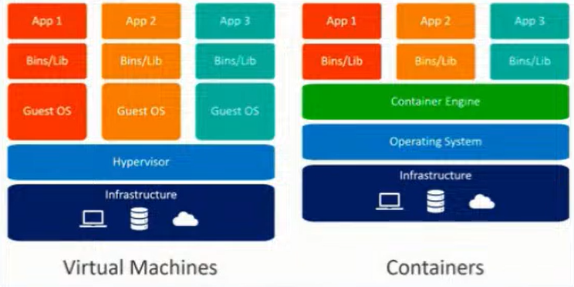

Първоначално е имало само виртуални машини.

Виртуална машина означава на даден хост машина/сървър да има изолирана операционна система, която можем да я ползваме без достъп до някакви други неща.

Идеята, ако има тази хост машина досттъчно ресурси, то да пуснем две незасивими изолирани виртуално операционни системи. Идеята е на всяка виртуална машина да се пуска един application.

Hypervisor – да дистрибутира и менъджира всички виртуални операционни системи и техните ресурси.

**Един Docker container е процес, а не цяла виртуална машина!** Една хост машина, една операционна система, различни процеси като един от тях е Docker cointainer!

В самият Docker container се казва също че има инсталирана малка операционна система – това всъщност не е съвсем вярно! Има файлова операционна система.

Docker Daemon(Docker engine) менъджира отделните контейнери.

* VMs virtualize the hardware
* Complete isolation
* Complete OS installation. Requires more resources
* Runs almost any OS
* Containers virtualize the OS
* Lightweight isolation
* Shared kernel among all the containers. Requires fewer resources
* Runs on the same OS == Linux

### Solutions

* **rkt** by CoreOS
  + Application container engine
  + <https://coreos.com/rkt>
* **Docker** byDocker Inc
  + Application container engine
  + <https://www.docker.com/>

### Containers Concepts (Docker View)

* **Container image** shows the state of a container, including registry or file system changes = все едно **container image** e нещо клас, а самия **контейнер** е нещо като клас. Самият container image e работещ container.
* **Container OS image** is the first layer of potentially many image layers that make up a container = основния image, върху който се гради контейнера
* **Container repository** stores container images and their dependencies = мястото, където се пазят тези container images

### Definitions

* Container
  + Containers are processes with much more isolation
* Image
  + Images provide a way for simpler software distribution

### Container layers



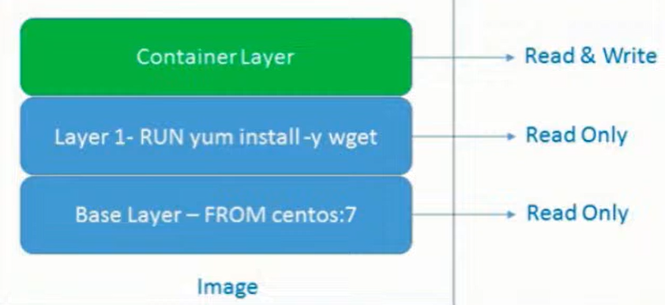

docker pull nginx

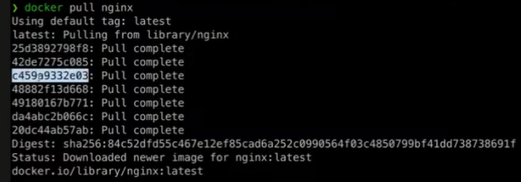

Като дръпнем един докер image, той сваля няколко слоя/layers с няколко id-та, като всеки layer е една от следните команди: FROM, MAINTAINER, RUN, COPY, ADD, EXPOSE, ENTRYPOINT, CMD.

Ако имаме едно и също начало на два докер файла за изпичане на image то при pull-ване на 2 различни Image-a, то те ще се преизползват – няма да ги дърпа два пъти! Т.е. всеки един layer се кешира поотделно и представлява определена част от тази lightweight файлова система. Това също означава, че image-те се оптимизират. Всички layer-и се кешират, с изключение на последния Read & Write layer.

Когато създадем нов контейнер от image, то само тогава се създава и то **наново Read & Write layer-a**.

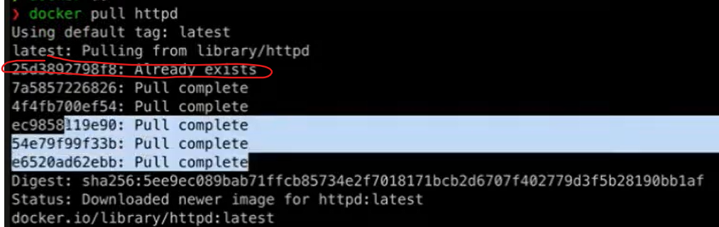

## 2.2. Docker

### Docker Engine

* Docker Mission – **Build**, **Ship**, **Deploy**
* Client-server application
* Components
  + dockerd daemon
  + REST API
  + docker CLI



### Registries – мястото, където се пазят тези images

* Provided by Docker
  + Cloud
    - Docker Hub (<https://hub.docker.com/explore/>)
    - Docker Store (<https://store.docker.com/>)
  + On-premise
* Provided by 3rd parties
  + Quay.io, Artifactory, Google Container Registry

### Workflow

**docker build** – създаване на docker image

**docker pull –** дърпане на image от регистри

**docker run** – стартирай ми контейнер

**docker push** – ако локално ние направим update и искаме нашия image да го дистрибутираме към регистрито.



Client – Docker CLI (Docker Command Line Interface)

Docker host – това реално е Docker engine-a == Docker daemon

Не е задължително CLI и Docker host да са на една и съща машина. Но в прости дема – това е една и съща машина.

Docker платформата върви само на Линукс. С други думи на Windows и на MacOS пуска виртуална машина на Линукс, за да може да запали Докера.

Registry – място където се споделят images – нещо като MVN repository

<https://hub.docker.com/>

## 2.3. Docker Installation

### What We Need to Know?

* **Two Editions** (Community and Enterprise)
* **Native Options**
  + Docker for Linux – без Desktop 😊
  + Docker Desktop for MAC
  + Docker Desktop for Windows
* **Docker Toolbox** (deprecated) - All-in-one solution
  + For Mac and Windows



## 2.4. Working with Docker

Docker е оптимизиран откъм бързина, но не и откъм дисково пространство

### Pull / Image Pull

* Purpose
  + Pull an image or a repository from a registry
* Old syntax

docker pull [OPTIONS] NAME[:TAG|@DIGEST]

* New syntax

docker image pull [OPTIONS] NAME[:TAG|@DIGEST]

* Example

docker image pull ubuntu:latest

### Run / Container Run

* Purpose
  + Run a command in a new container
* Old syntax

docker run [OPTIONS] IMAGE [COMMAND] [ARG]

docker run -it ubuntu :latest //-it идва от interactive TTY – да имаме достъп отвън до контейнера отвътре

docker run -it ubuntu :latest /bin/bash стартирай ми контейнера с имидж Ubuntu, и стартирай отвътре bash-a

docker run -it nginx самият nginx може да пуска web приложение

docker run -p 8080:80 nginx **-p** опция за forwarding of traffic (port forwarding)

**Лявата страна на порта “8080:8080” е на нашата линукс сървърна машина, а дясната страна на порта е каквото е вътре в пуснатия един или няколко контейнера от image nginx.**

docker run -d -p 8080:80 nginx **-d** опция за пускане на процеса в background/long run – като се изпълни процеса, то процеса остава и не се самоизчиства!

docker run -d -p 8081:80 nginx



* New syntax

docker container run [OPTIONS] IMAGE [COMMAND] [ARG]

* Example

docker container run -it ubuntu

### Exec

Ако имаме няколко контейнера активни, то в нов терминал да си достъпим отвътре някой действащ контейнер примерно.

Runs a new command in a running container.



docker exec -it hardcore_torvalds bash

docker exec -it 5bd bash само с част от container id-то стават доста от докер командите

### Kill



docker kill 5bd само с част от container id-то стават доста от докер командите

### Prune

Deletes both containers and images

**docker system prune -a**

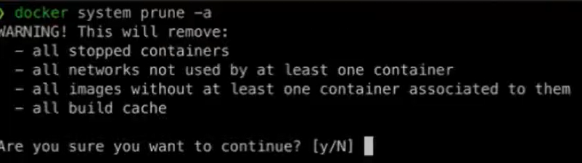

### Run container with a specific volume / Bind Mount

docker run -d -p 8080:80 **-v** /tmp/nginx:/user/share/nginx/html nginx

Рънни контейнер от nginx имидж, като копирай всичко от папка /tmp/nginx вътре в контейнера на път /user/share/nginx/html – като **-v** указва, че един вид това е volume. В случая този ред означава **Bind Mount** – директна връзка между външния свят и контейнра вътре, и е по-различно от volume. Volume заема произволно място на хост машината, докато в нашия случай ние сме си направили папка отвън, която да се копира вътре в контейнера.

### Images / Image Ls

* Purpose
  + List locally available images
* Old syntax

docker images [OPTIONS] [REPOSITORY[:TAG]]

* New syntax

docker image ls [OPTIONS] [REPOSITORY[:TAG]]

* Example

docker image ls fedora

### Image inspect

**docker image inspect my-java-app**

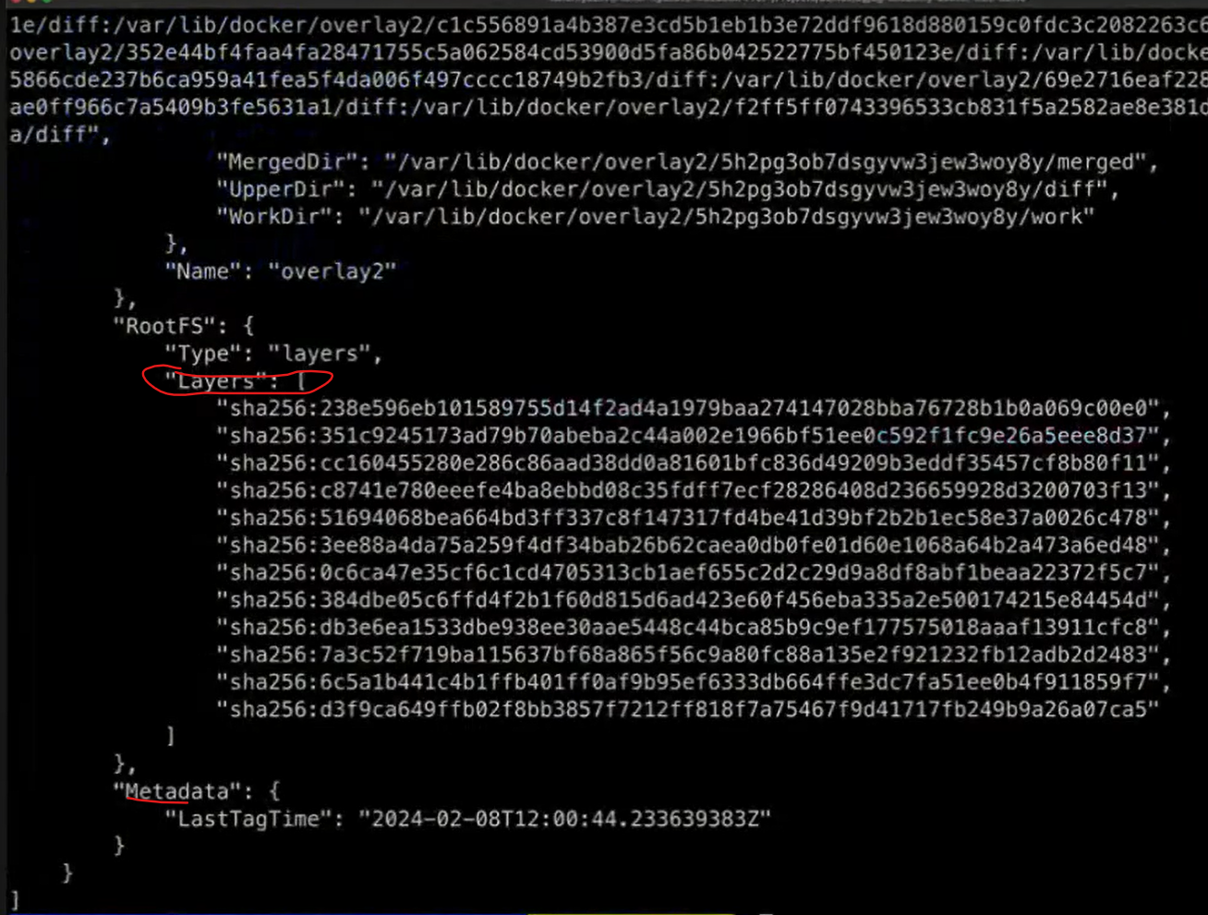



### Ps / Container Ls

* Purpose
  + List containers
* Old syntax

docker ps [OPTIONS]

* New syntax

docker container ls [OPTIONS]

* Example

docker container ls –a -q

### Rm / Container Rm

* Purpose
  + Remove one or more containers
* Old syntax

docker rm [OPTIONS] CONTAINER [CONTAINER]

* New syntax

docker container rm [OPTIONS] CONTAINER [CONTAINER]

* Example

docker container rm weezy_snake

### Rmi / Image Rm

* Purpose
  + Remove one or more images
* Old syntax

docker rmi [OPTIONS] IMAGE [IMAGE]

* New syntax

docker image rm [OPTIONS] IMAGE [IMAGE]

* Example

docker image rm ubuntu fedora

### Start / Container Start

* Purpose
  + Start one or more stopped containers
* Old syntax

docker start [OPTIONS] CONTAINER [CONTAINER]

* New syntax

docker container start [OPTIONS] CONTAINER [CONTAINER]

* Example

docker container start -a -i 0cbf27183

### Restart / Container Restart

* Purpose
  + Restart a one or more containers
* Old syntax

docker restart [OPTIONS] CONTAINER [CONTAINER]

* New syntax

docker container restart [OPTIONS] CONTAINER [CONTAINER]

* Example

docker container restart 0cbf27183

### Stop / Container Stop

* Purpose
  + Stop one or more running containers
* Old syntax

docker stop [OPTIONS] CONTAINER [CONTAINER]

* New syntax

docker container stop [OPTIONS] CONTAINER [CONTAINER]

* Example

docker container stop 0cbf27183

### Unpause / Container Unpause

* Purpose
  + Unpause all processes within one or more containers
* Old syntax

docker unpause CONTAINER [CONTAINER]

* New syntax

docker container unpause CONTAINER [CONTAINER]

* Example

docker container unpause 0cbf27183

### Attach / Container Attach

* Purpose
  + Attach to a running container
* Old syntax

docker attach [OPTIONS] CONTAINER

* New syntax

docker container attach [OPTIONS] CONTAINER

* Example

docker container attach 0cbf27183

docker -exec ……

### Push / Image Push

* Purpose
  + Push an image or repository to a registry
* Old syntax

docker push [OPTIONS] NAME[:TAG]

* New syntax

docker image push [OPTIONS] NAME[:TAG]

* Example

docker image push repo-name/test:latest

### Login to Docker registry

* Purpose
  + Log into a Docker registry
* Old syntax

docker login [OPTIONS] [SERVER]

* New syntax

docker login [OPTIONS] [SERVER] като стария синтаксис

* Example

docker login

### Logout from Docker registry

* Purpose
  + Log out from a Docker registry
* Old syntax

docker logout [SERVER]

* New syntax

docker logout [SERVER] като стария синтаксис

* Example

docker logout

## 2.5. Image from DockerFile – изпичане на docker файл

### General Structure (Dockerfile)

* Script, composed of commands and arguments
* Always begins with FROM instruction

*# Set the base image*

FROM nginx Comment

*# Set the maintainer*

MAINTAINER John Smith Command (Instruction)

*# Copy files*

COPY index.html /usr/share/nginx/html/

### FROM

* Purpose
  + Defines the base image to use to start the build process
* Syntax

FROM <image>[:<tag>] [AS <name>]

* Example

*# it is a good practice to state a version (tag)*

FROM ubuntu:18.04

*# for the latest version the tag could be skipped*

FROM ubuntu

### MAINTAINER

* Purpose
  + Sets the author field of the image. It is deprecated
* Syntax

MAINTAINER <name>

* Example

*# deprecated*

MAINTAINER John Smith

*# newer variant is this:*

LABEL maintainer="John Smith"

### RUN

* Purpose
  + Used during build process to add software (forms another layer)
* Syntax

RUN <command>

* Example

*# single command*

RUN apt-get -y update

*# more than one command*

RUN apt-get -y update && apt-get -y upgrade

### COPY

* Purpose
  + Copy files between the host and the container
* Syntax

COPY [--chown=<user>:<group>] <src>... <dest>

* Example

*# Copy single file*

COPY readme.txt /root

*# Copy multiple files*

COPY *.html /var/www/html/my-web-app

### ADD

* Purpose
  + Copy files to the image
* Syntax

ADD [--chown=<user>:<group>] <src>... <dest>

* Example

*# Add single file from URL*

ADD https://softuni.bg/favicon.ico /www/favicon.ico

*# Add tar file content*

ADD web-app.tar /var/www/html/my-web-app

### EXPOSE

* Purpose
  + Informs Docker that the container listens on the specified ports
* Syntax

EXPOSE <port> [<port>/<protocol>...]

* Example

*# single port*

EXPOSE 80

*# multiple ports*

EXPOSE 80 8080

### ENTRYPOINT

* Purpose
  + Allows configuration of container that will run as an executable
  + **Задължителната команда, която ще се изпълни в началото**
* Syntax

*# exec form, this is the preferred form*

ENTRYPOINT ["executable", "param1", "param2"]

*# shell form*

ENTRYPOINT command param1 param2

### CMD

* Purpose
  + Main purpose is to provide defaults for an executing container
  + **Дефаултната команда, която ще се изпълни в началото**
* Syntax

*# exec form, this is the preferred form*

CMD ["executable","param1","param2"]

*# as default parameters to ENTRYPOINT*

CMD ["param1","param2"]

*# shell form*

CMD command param1 param2

### CMD vs ENTRYPOINT

* Both **define** what **command** gets **executed** when **running** a container
* **Dockerfile** should specify at **least** **one** of them
* **ENTRYPOINT** should be defined when using the **container** as an **executable**
* **CMD** should be used as a way of defining **default** **arguments** for an **ENTRYPOINT** command or for **executing** an **ad-hoc** command in a container
* **CMD** will be overridden when **running** the container with **alternative** arguments
* Both have **exec** and shell **form**
* When used **together** **always** use their **exec** form

Когато се използват заедно или поотделно:

CMD командата може да заема няколко аргумента



### Build / Image Build

* Purpose
  + Build an image from a Dockerfile
* Old syntax

docker build [OPTIONS] PATH | URL | -

* New syntax

docker image build [OPTIONS] PATH | URL | -

* Example - **-t** означава сложи му таг, а точката е текущата директория

**docker image build -t new-image** **.**

Ако създаваме локално docker image на M1, M2, M3 MacOS компютър (ARM или ARM64 процесорна архитектура), то би имало проблем този имидж като го качим в регистрито и други потребители си го изтеглят и пуснат контейнер на обикновен Линукс. Затова ако сме на MacOS пускаме следната команда и тогава е доста голям шанса да работи:

**docker build buildx –platform linux/amd64 my-java-app .**

Доста често в практиката тези docker images се билдват от Jenkins/GitHub actions агенти, и тъй като се билдват (чрез buildАаА.yml) на Линукс сървър, тогава го нямаме този проблем с ARM64! T.e. преместваме създаването/ изпичането на докер image в CI/CD pipeline-a.

### Dockerfile example workflow

#### Example 1:

Dockerfile-build

# We start from openjdk17 base image to have JDK installed

FROM eclipse-temurin:17-jdk  
WORKDIR /app   
  
COPY build/libs/petclinic-0.0.1-SNAPSHOT.jar app.jar //копирай jar файла като app.jar вътре в контейнера  
  
CMD [”java”, ”-jar”, ”app.jar”] //Read & Write layer

In the terminal:

**docker build -t my-java-app . -t** означава сложи му таг, а точката е текущата директория

docker run -p -d 8080:8080 **my-java-app**

#### Example 2:

Dockerfile-build

# We start from openjdk17 base image to have JDK installed

FROM eclipse-temurin:17-jdk  
WORKDIR /app //same as RUN mkdir app && cd app

//организираме layers по честота на промяна – т.е. src ще се променя често, тогава измести копиранията за gradle по-горе – това ще ги сложи в кеша за следващ image build ще се изпълнява по-бързо   
COPY gradlew . //копирай gradlew файла вътре в контейнера  
COPY gradle gradle/ //копирай съдържанието на gradle папката вътре в контейнера в директория gradle/  
COPY build.gradle.kts .  
COPY settings.gradle.kts .  
  
COPY src src/ //копирай съдържанието на src папката вътре в контейнера в директория src/  
RUN ./gradlew **bootJar**  
  
EXPOSE 8080  
  
CMD sh -c 'java -jar build/libs/*.jar' //Read & Write layer

In the terminal:

**docker build -t my-java-app . -t** означава сложи му таг, а точката е текущата директория

След като image-a e изпечен/създаден, то може да пуснем container от него:

**docker run -it my-java-app /bin/bash**

#### Example 3 – with maven offline:

Dockerfile-build

# We start from openjdk17 base image to have JDK installed

FROM eclipse-temurin:17-jdk  
WORKDIR /app //same as RUN mkdir app && cd app

COPY maven???*** .

# 3 layers runs

RUN apt update

RUN apt install java

RUN apt install python

# preferable to be only 1 layer instead of 3 layers!!!

RUN apt update && apt install java && apt install python

RUN mvn dependencies:go-offline

COPY src src/

RUN ./mvnw **package**  
  
EXPOSE 8080  
  
CMD sh -c 'java -jar build/libs/*.jar'

#### Example 4 – multistage

Заема по-малко място самият готов изпечен image

Dockerfile-multistage

# phase 1

FROM eclipse-temurin:**17-jdk** AS *build*WORKDIR /app  
  
COPY gradlew .  
COPY gradle gradle/  
COPY build.gradle.kts .  
COPY settings.gradle.kts .  
  
COPY src src/  
RUN ./gradlew bootJar

# phase 2 – run the jar file

FROM eclipse-temurin:**17-jre**  
WORKDIR /app  
  
COPY --from=*build* /app/build/libs/*.jar app.jar  
  
EXPOSE 8080  
CMD sh -c 'java -jar app.jar'

docker build -t "petclinic" -f Dockerfile-multistage .

### Recommendations

* Don’t create large images
* Don’t use only the “latest” tag
* Don’t run more than one process in a single container
* Don’t rely on IP addresses
* Put information about the author

## 2.6. Demo summary + Gradle Wrapper and Gradle for Windows

### Gradle

<https://tomgregory.com/what-is-the-gradle-wrapper-and-why-should-you-use-it/>

The Gradle wrapper is a script you add to your Gradle project and use to execute your build. The advantages are:

you don’t need to have Gradle installed on your machine to build the project

the wrapper guarantees you’ll be using the version of Gradle required by the project

you can easily update the project to a newer version of Gradle, and push those changes to version control so other team members use the newer version





gradle init

Running a build

gradle build

**gradle clean build**

When you run the **build** command you’ll see output like this.

This means that your application was assembled and any tests passed successfully. Gradle will have created a build directory if it didn’t already exist, containing some useful outputs you should be aware of.

1. **the *classes*directory**contains compiled .class files, as a result of running the Java compiler against your application Java source files
2. **the *libs* directory**contains a generated jar file, an archive with all your compiled classes inside **ready to be executed or published** – ако махнем версията от build.gradle, то .jar файловете ще са с по-кратки имена.
3. 
4. **the *reports*directory**contains an HTML report summarising your test results. If your build fails, then consult this report to see what went wrong.

You now know that running the Gradle build command is equivalent to running the build task, which you do in Windows with gradlew build and on Linux/Mac with ./gradlew build. The build task depends on other tasks, and in some situations it may make sense to run a more specific task.

След което можем да го пуснем/run-нем този jar

**java -jar ./build/libs/docker.jar**

За да създадем .jar файл с Gradle, то тестовете трябва да минават

### Maven

За да създадем .jar файл с Maven, то тестовете трябва да минават

### Файлът /deployment/**Dockerfile**:



**FROM** openjdk:11-jre

**VOLUME /**tmp  
**COPY build/libs/**docker.jar app.jar  
**ENTRYPOINT** [**"java"**,**"-Djava.security.egd=file:/dev/./urandom -Xms256m -Xmx512m"**, **"-jar"**,**"/app.jar"**]

Ако използваме Maven, тези думички били различни

**build/libs**

От основната директория на проекта ни, под CMD на Windows пускаме следната команда

C:\Temp projects\Spring Advanced\12 Containerization & Documentation\docker_example>

**docker build -t svilenvelikov/demo1:v1 -f deployment/Dockerfile .**

създай от .jar файла **image** с име demo1 версия 1 на user svilenvelikov и от текущата директория която е точка, изпълни Dockerfile.

### docker images

в терминала показва всички имиджи качени на докер към момента



Можем да ги видим и от приложението DockerDesktop



### I) Пускане на docker image-а

C:\Temp projects\Spring Advanced\12 Containerization & Documentation\docker_example>

**docker run -p 8080:8080 svilenvelikov/demo1:v1**

Когато image-а се run-не, то той става контейнер.

### docker ps

покажи текущо активни контейнери

### Kaчи image-a на облака **docker repositories**

**docker push svilenvelikov/demo2:v2**

останалите images са част от jdk и няма нужда да се пушват



### Remove-ване на спрян контейнер

При опит да изтрием docker image:

Error response from daemon: conflict: unable to delete **5d4cfe7396db** (must be forced) - image is being used by stopped container **d61b2cca0024**

PS C:\Temp projects\Spring Advanced\12 Containerization & Documentation\docker_example> **docker rm d61b2cca0024**

### Remove-ване на самия docker image

PS C:\Temp projects\Spring Advanced\12 Containerization & Documentation\docker_example> **docker rmi 5d4cfe7396db**

Untagged: svilenvelikov/demo2:v2

Untagged: svilenvelikov/demo2@sha256:3232e698c894f814aea10bb0e5ecbd61af3562e9b8bdea73dab5cb4d49acc547

Deleted: sha256:5d4cfe7396db1e26c28c46c664427ad0041b8afa23c23aeb5c8f4b28091e9ac6

### Търси първо локално, след това търси от облака

Ако пуснем команда за рънване на изтрития локално image, то първо търси локално, след това търси на облака docker repositories

**docker run -p 8080:8080 svilenvelikov/demo2:v2**

PS C:\Temp projects\Spring Advanced\12 Containerization & Documentation\docker_example> docker run -p 8080:8080 svilenvelikov/demo2:v2

Unable to find image 'svilenvelikov/demo2:v2' locally

v2: Pulling from svilenvelikov/demo2

001c52e26ad5: Already exists

d9d4b9b6e964: Already exists

2068746827ec: Already exists

8510da692cda: Already exists

b6d84395b34d: Already exists

bf03fea6c3ad: Already exists

7ac2c538825b: Already exists

Digest: sha256:3232e698c894f814aea10bb0e5ecbd61af3562e9b8bdea73dab5cb4d49acc547

Status: Downloaded newer image for svilenvelikov/demo2:v2

### II) Пускане на повече docker images - как 2 image-а си говорят когато са качени на Docker

PS C:\Temp projects\Spring Advanced\12 Containerization & Documentation\docker_example>

Docker Compose is **a tool that was developed to help define and share multi-container applications**. With Compose, we can create a YAML file to define the services and with a single command, can spin everything up or tear it all down.

**docker-compose -f ./local/local.yaml up**

**docker-compose -f ./local/local.yaml down**

**Ако нямаме локално инсталиран MySQL например**



**version**: **'3.3'  
services**:  
 **db**:  
 **image**: arm64v8/mysql:oracle  
 **ports**:  
 - **"3306:3306"  
 command**: [**'--character-set-server=utf8mb4'**, **'--collation-server=utf8mb4_bin'**, **'--default-authentication-plugin=mysql_native_password'**]  
 **environment**:  
 - MYSQL_ALLOW_EMPTY_PASSWORD="yes"  
 - MYSQL_DATABASE=intro  
 **docker-demo**:  
 **image**: svilenvelikov/docker-demo:v3  
 **ports**:  
 - **"8080:8080"** *# web ui* **environment**:  
 - **MYSQL_HOST**=db  
 - MYSQL_USER=root  
 - MYSQL_PASSWORD=



**application.yml**

**spring**:  
 **datasource**:  
 **driverClassName**: com.mysql.cj.jdbc.Driver  
 **url**: **"jdbc:mysql://${MYSQL_HOST:localhost}:3306/demodocker?useSSL=false&createDatabaseIfNotExist=true&serverTimezone=UTC"  
 username**: **"${MYSQL_USER:root}"  
 password**: **"${MYSQL_PASSWORD:}"**

### III) Пускане на docker image с CMD опция

При стартиране на docker image-а да прави ping

При първата команда ping-ва от локалния сървър localhost/от локалния компютър.

При втората команда овъррайдваме CMD-то да бъде google.com и сега ping-ва от google.com

ENTRYPOINT не може да се override-не



# 3. Kubernetes and orchestration

## History Overview

* At the beginning software was mostly installed **on prem** (on physical hardware)
* Then the cloud paradigm started emerging and **hypervisors** like VirtualBox and HyperV became important players in that area
* However virtualization posed significant limitations due to the strict isolation of VMs in terms of resources (CPU and memory)
* The evolution of hardware and operating systems provided the better possibilities to run applications as separate isolated processes
* An example of such possibilities are **namespaces** and **cgroups** in the Linux Kernel – изолираме ресурсите като памет и процесор за всеки процес без да е нужно външно приложение като **hypervisor**
* This enabled the implementation of container solutions like Docker
* However, the use of container technology like Docker still implied a lack of good tooling to automate the process of management and orchestration of the containers:
  + How do we manage configuration of containers?
  + How do we scale up/down using containers? (i.e. Docker Swarm)
  + How do we automate deployment of a group of containers? (i.e. Ansible scripts or Docker compose)
  + How do we manage the administrative aspects of a container (i.e. networking, traffic redirection, security, resource allocation, etc…)
* Due to the increasing needs to optimize resources utilization and management aspects of containers Google developed Borg as an internal large-scale cluster management system
* Borg allowed Google to run thousands of jobs from a number of applications
* Borg was later succeeded by Omega as a second generation cluster management system which emerged at about the same time as Docker
* Thus Kubernetes was born out of the idea to combine the possibilities of a container technology like Docker with a scalable cluster management system like Borg….

## Architecture

<https://kubernetes.io/docs/concepts/architecture/>

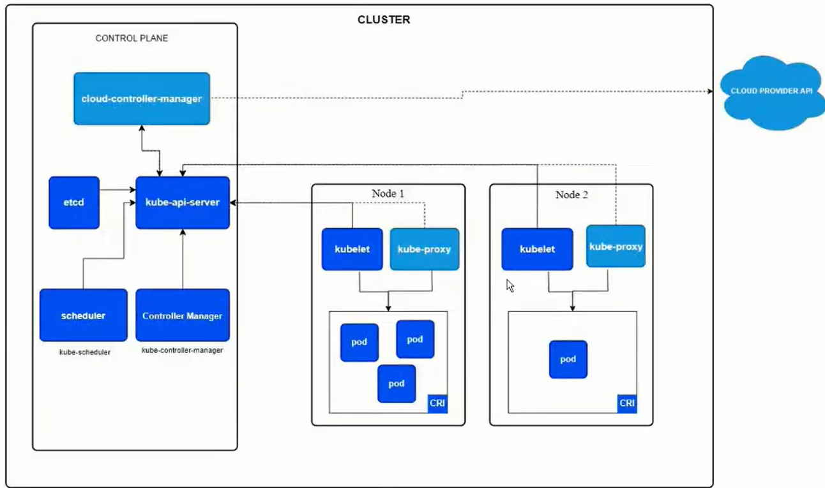

**Control Plane** – на отделна физическа машина

**etcd** – разпределена файлова система, която се използва за да persist-ва цялата информация в Kubernetes cluster-а.

**kube-api-server** – rest interface, с който можем да менъджираме различните елементи в Kubernetes клъстера. На Java, C#, Python, и т.н. Този kube-api-server менъджира също node-вете.

**node** – виртуална машина или физическа машина или набор от няколко мощни сървъра - машина на която да се деплойват **pod**-вете

**kubelet** – комуникира двустранно – с kube-api-server и с pod-вете. Като менъджира pod-вете. С други думи kube-api-server казва на kubelet-a стартирай ми pod с тези и тези контейнери на този node в клъстера.

**kube-proxy** – се грижи да ротира трафика към pod-овете в рамките на node-a.

**scheduler** – се грижи за стартирването на pod-вете в node-вете – като например кой node има достатъчно ресурси в момента да стартира дадения pod.

**Controller Manager** – се грижи да изпълнява различни процеси/задачи – като си минава по пътя kube-api-server -> kubelet:

* + като например деплоймент на приложение – еднократни job-ве от рода на стартирай нов node и му сложи първоначални pod-ве.
  + Ако даден node не е reachable, то да го маркира да не се деплойват на него pod-ве в момента.
  + Replicaset-controller – да се погрижи да има поне една инстанция например за nginx **pod**-a

**Cloud-controller-manager** – API, което може да се имплементира от различни Cloud providers (GoogleCloudProvider, AmazonWebServices). Дава възможност да се менъджират различни дейности в рамките на съответния cloud provider, последния който деплойва Kubernetes cluster.

### Pod

* The basic unit of operation in Kubernetes is a **pod**
* A **pod** may contain one or more containers (Docker containers for example)
* **Pods** are logically grouped in Kubernetes **namespaces** – не е задължително да използваме namespaces, но когато организацията е голяма определни хора или тиймове да имат определени права свързани с този namespace
* **Namespaces** provide isolation of resources, users and permissions
* За всеки един pod се алокира отделен IP address

### Workload

* Workloads are a logical grouping of pods that form an application
* Workloads in Kubernetes can be different types – in yaml syntaxis:
  + ReplicaSets – как да репликираме даден pod
  + Deployments – описание как можем да деплойваме pod
  + StatefulSets
  + DaemonSets

### Services

Контейнерите на всеки pod могат да стартирват на определени портове. Но за всеки отделен pod се алокира отделен IP address.

Всички pod-s от даден node са организирани в т.нар. клъстерна мрежа.

За да може един pod да достъпи сървиси от друг pod, то не е видимо как да стане от самите контейнери! За да може това нещо да се реализира, то имаме т.нар. сървиси/services.

* As the name implies: provides the possibility to define a ‘service’ on top of pods
* The service has an IP address, port and a DNS name
* The service provides the possibility to route traffic to pods either from inside the Kubernetes cluster or from outside
* A service is also described in yaml file

### Ingress

Ако искаме да ротираме трафик между подовете на базата на конкретни правила.

* Ingress elements provide the possibility to route traffic to pods
* It can be configured on a rule-basis specifying how traffic coming to the cluster can be routed to pods
* Ingress routes traffic to services – тези правила са вече декларирани в **service** yaml файловете.

### ConfigMaps

* ConfigMaps are the main mechanism used to supply configuration to pods
* That configuration can be passed in either of two ways from a ConfigMap to a pod:
  + As environment variables
  + Mounted on a pod container’s file system

### Secrets

* Secrets like ConfigMaps can be used to store configuration data
* Secrets are intended to store **sensitive data (such as passwords and certificates)**
* Data stored as Kubernetes secrets is not encrypted-at-rest by default
* Secrets can also be derived from external access management applications like HashiCorp Vault or Keycloak, etc.

Имаме няколко различни механизма, с които можем да интегрираме Keycloak в Kubernetes:

* + Ако сме на Spring/Quarkus проект – самият проект ни дава възможност да се интегрираме с Keycloak
  + Kubernetеs може да извлича данни от Keycloak и да ги записва като Kubernetes secrets

### Volumes

* Containers provide by default temporary storage that is wiped out on container restart (in the case of Kubernetes – a pod restart)
* Kubernetes provides the possibility to create and manage persistent volumes used by the pods
* Volumes can be mounted to the file system on a pod container – например да пазим данни в база данни

## Deployment and tools

### One local instance of Kubernetes

* Deploying a Kubernetes cluster form scratch is not a trivial task…
* For that purpose for local development there are a number of options available like:
  + **minikube – една инстанция на една виртуална машина или на един докер контейнер**
  + Kind
  + K3s
  + MicroK8s
  + Kubeadm
  + DockerDesktop with installed also Kubernetes plugin run in a docker container

### API clients

* **kubectl** – standard (and most used) CLI client for Kubernetes

kubectl create deployment nginx --image nginx //create deployment е по-скоро за локално тестване

kubectl apply -f deployment.yaml

kubectl get pods -n somenamespace

kubectl describe pod pod_id -n somenamespace какви контейнери и други неща в дадения под

kubectl logs pod_id -n somenamespace по подразбиране се листват логовете на първия контейнер от пода

kubectl logs pod_id -c containerid -n somenamespace

* language API clients (i.e. for Java)
* other tools – like **k9s**

### Web UIs

Different third party web interfaces for managing Kubernetes:

* + **Kubernetes Dashboard** (standard and most popular)
  + Kubernetes Lens (IDE for Kubernetes)
  + Octant
  + others

### Package management

* **Helm** is a widely used package manager for Kubernetes
* It is used to build distributable **charts** that are packages of Kubernetes resources
* Charts са група от Kubernetes ресурси – например deploy.yaml, който деплойва **pod** с nginx и Spring приложение с/на 3 инстанции, services, ConfigMaps, и т.н.
* Тези **charts** можем да ги създаваме, да ги качваме в централно Helm хранилище, и да бъдат преизползвани в различни Kubernetes клъстери.
* Charts can be stored in a central repository and used by applications

Инсталираме първо helm.

След това:

**helm install petclinic k8s/charts**

values.yaml

namespace: petclinic  
app:  
 name: petclinic  
 image: petclinic  
 tag: latest  
 pullPolicy: IfNotPresent  
 port: 8080  
 serviceType: LoadBalancer  
 replicas: 4  
db:  
 name: postgres  
 image: postgres  
 tag: latest  
 port: 5432  
 serviceType: ClusterIP  
 replicas: 1  
 username: petclinic  
 password: petclinic  
 database: petclinic

apiVersion: apps/v1  
kind: Deployment  
metadata:  
 name: {{ .Values.app.name }}-deployment  
 namespace: {{ .Values.namespace }}  
spec:  
 replicas: {{ .Values.app.replicas }}  
 selector:  
 matchLabels:  
 app: {{ .Values.app.name }}  
 template:  
 metadata:  
 labels:  
 app: {{ .Values.app.name }}  
 spec:  
 containers:  
 - image: "{{ .Values.app.image }}:{{ .Values.app.tag }}"  
 imagePullPolicy: {{ .Values.app.pullPolicy }}  
 name: {{ .Values.app.name }}  
 env:  
 - name: SPRING_PROFILES_ACTIVE  
 value: {{ .Values.db.name }}  
 - name: SPRING_DATASOURCE_URL  
 value: jdbc:postgresql://{{ .Values.db.name }}-service:{{ .Values.db.port }}/{{ .Values.db.database }}  
 ports:  
 - name: http  
 containerPort: {{ .Values.app.port }}  
 protocol: TCP  
 restartPolicy: Always

## Installing

### Combination 1

1) DockerEngine Или DockerDesktop

2) kubectl

<https://kubernetes.io/docs/tasks/tools/>

kubectl version –client

3) minikube

<https://minikube.sigs.k8s.io/docs/start/>

Add the minikube.exe binary to your PATH.  
*Make sure to run PowerShell as Administrator.*

$oldPath = [Environment]::GetEnvironmentVariable('Path', [EnvironmentVariableTarget]::Machine)

if ($oldPath.Split(';') -inotcontains 'C:\minikube'){

[Environment]::SetEnvironmentVariable('Path', $('{0};C:\minikube' -f $oldPath), [EnvironmentVariableTarget]::Machine)

}

K8S === Kubernetes //8 букви между K и S

### Combination 2

Use DockerDesktop with Kubernetes plugin enabled

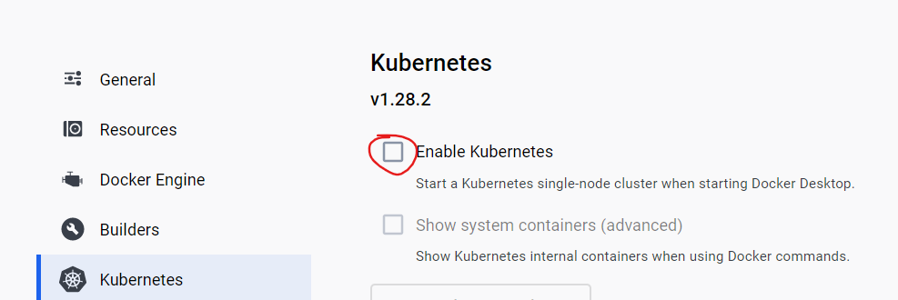

minikube not needed in this option

## Some commands:

minikube start –driver=docker

docker ps

kubectl get pods

kubectl get pods -A all including system

kubectl create deployment nginx --image nginx

Основната разлика между Kubernetes и Docker(и Docker compose) е, че вече минаваме към декларативен начин на работа – чрез въпросните yaml файлове за Kubernetes:

C:\Windows\System32>**kubectl run nginx --image nginx** //създава си служебен yaml файл

pod/nginx created

C:\Windows\System32>**kubectl get pods**

NAME READY STATUS RESTARTS AGE

nginx 1/1 Running 0 84s

C:\Windows\System32>**kubectl delete pod nginx**

pod "nginx" deleted

C:\Windows\System32>**kubectl delete pod/nginx**

pod "nginx" deleted

C:\Windows\System32>**kubectl run nginx --image nginx -o yaml** //-o принтни служебно създадения yaml файл

**apiVersion: v1**

**kind: Pod**

metadata:

creationTimestamp: "2024-08-15T11:38:32Z"

labels:

run: nginx

name: nginx

namespace: default

resourceVersion: "14000"

uid: 67bb5e2b-f0cd-482c-9663-196c6fef2a0e

spec:

containers:

- image: nginx

imagePullPolicy: Always

name: nginx

resources: {}

terminationMessagePath: /dev/termination-log

terminationMessagePolicy: File

volumeMounts:

- mountPath: /var/run/secrets/kubernetes.io/serviceaccount

name: kube-api-access-knh6t

readOnly: true

dnsPolicy: ClusterFirst

enableServiceLinks: true

preemptionPolicy: PreemptLowerPriority

priority: 0

restartPolicy: Always

schedulerName: default-scheduler

securityContext: {}

serviceAccount: default

serviceAccountName: default

terminationGracePeriodSeconds: 30

tolerations:

- effect: NoExecute

key: node.kubernetes.io/not-ready

operator: Exists

tolerationSeconds: 300

- effect: NoExecute

key: node.kubernetes.io/unreachable

operator: Exists

tolerationSeconds: 300

volumes:

- name: kube-api-access-knh6t

projected:

defaultMode: 420

sources:

- serviceAccountToken:

expirationSeconds: 3607

path: token

- configMap:

items:

- key: ca.crt

path: ca.crt

name: kube-root-ca.crt

- downwardAPI:

items:

- fieldRef:

apiVersion: v1

fieldPath: metadata.namespace

path: namespace

status:

phase: Pending

qosClass: BestEffort

Доста от служебно създадените неща за yaml файла са излишни.

D:\_GitHub locale\BGJUG-public\bgjug-academy-docker-k8s-demo-main> **kubectl apply -f k8s/app-service.yaml**

D:\_GitHub locale\BGJUG-public\bgjug-academy-docker-k8s-demo-main> **kubectl get all**

NAME READY STATUS RESTARTS AGE

pod/nginx 1/1 Running 0 11m

NAME TYPE CLUSTER-IP EXTERNAL-IP PORT(S) AGE

service/kubernetes ClusterIP 10.96.0.1 <none> 443/TCP 3h3m

За следене на промени в терминала да се зареждат автоматично – този watch е допълнителен plug-in

**watch -kubectl get all**

**app-deployment.yaml**

apiVersion: apps/v1  
**kind: Deployment**  
metadata:  
 name: petclinic-deployment  
 namespace: petclinic  
spec:  
 **replicas: 1** //една инстанция в случая - това нещо Docker и Docker Compose не могат да го направят!   
 selector:  
 matchLabels:  
 app: petclinic  
 **template:**  
 metadata:  
 labels:  
 app: petclinic  
 spec:  
 **containers:**  
 - image: petclinic:latest  
 name: petclinic  
 imagePullPolicy: IfNotPresent  
 env:  
 - name: SPRING_PROFILES_ACTIVE  
 value: postgres  
 - name: SPRING_DATASOURCE_URL  
 value: jdbc:postgresql://postgres-service:5432/petclinic  
 ports:  
 - name: http  
 containerPort: 8080  
 protocol: TCP  
 restartPolicy: Always

**app-service.yaml**

apiVersion: v1  
**kind: Service**  
metadata:  
 name: petclinic-service  
 namespace: petclinic  
spec:  
 ports:  
 - name: http  
 port: 8080  
 targetPort: 8080  
 **selector**:  
 app: petclinic  
 **type: LoadBalancer** #ClusterIP NodePort

C:\Windows\System32>**kubectl get pods**

NAME READY STATUS RESTARTS AGE

nginx 1/1 Running 0 22m

**Логовете**

C:\Windows\System32>**kubectl logs nginx**

/docker-entrypoint.sh: /docker-entrypoint.d/ is not empty, will attempt to perform configuration

/docker-entrypoint.sh: Looking for shell scripts in /docker-entrypoint.d/

/docker-entrypoint.sh: Launching /docker-entrypoint.d/10-listen-on-ipv6-by-default.sh

10-listen-on-ipv6-by-default.sh: info: Getting the checksum of /etc/nginx/conf.d/default.conf

10-listen-on-ipv6-by-default.sh: info: Enabled listen on IPv6 in /etc/nginx/conf.d/default.conf

/docker-entrypoint.sh: Sourcing /docker-entrypoint.d/15-local-resolvers.envsh

/docker-entrypoint.sh: Launching /docker-entrypoint.d/20-envsubst-on-templates.sh

/docker-entrypoint.sh: Launching /docker-entrypoint.d/30-tune-worker-processes.sh

/docker-entrypoint.sh: Configuration complete; ready for start up

2024/08/15 11:38:33 [notice] 1#1: using the "epoll" event method

2024/08/15 11:38:33 [notice] 1#1: nginx/1.27.0

2024/08/15 11:38:33 [notice] 1#1: built by gcc 12.2.0 (Debian 12.2.0-14)

2024/08/15 11:38:33 [notice] 1#1: OS: Linux 5.15.133.1-microsoft-standard-WSL2

2024/08/15 11:38:33 [notice] 1#1: getrlimit(RLIMIT_NOFILE): 1048576:1048576

2024/08/15 11:38:33 [notice] 1#1: start worker processes

2024/08/15 11:38:33 [notice] 1#1: start worker process 29

2024/08/15 11:38:33 [notice] 1#1: start worker process 30

2024/08/15 11:38:33 [notice] 1#1: start worker process 31

2024/08/15 11:38:33 [notice] 1#1: start worker process 32

2024/08/15 11:38:33 [notice] 1#1: start worker process 33

2024/08/15 11:38:33 [notice] 1#1: start worker process 34

2024/08/15 11:38:33 [notice] 1#1: start worker process 35

2024/08/15 11:38:33 [notice] 1#1: start worker process 36

2024/08/15 11:38:33 [notice] 1#1: start worker process 37

2024/08/15 11:38:33 [notice] 1#1: start worker process 38

2024/08/15 11:38:33 [notice] 1#1: start worker process 39

2024/08/15 11:38:33 [notice] 1#1: start worker process 40

2024/08/15 11:38:33 [notice] 1#1: start worker process 41

2024/08/15 11:38:33 [notice] 1#1: start worker process 42

2024/08/15 11:38:33 [notice] 1#1: start worker process 43

2024/08/15 11:38:33 [notice] 1#1: start worker process 44

2024/08/15 11:38:33 [notice] 1#1: start worker process 45

2024/08/15 11:38:33 [notice] 1#1: start worker process 46

2024/08/15 11:38:33 [notice] 1#1: start worker process 47

2024/08/15 11:38:33 [notice] 1#1: start worker process 48

**kubectl delete deploy nginx-deployment**

**kubectl delete deployment nginx-deployment**

Идеята на контекста, е че можем да достъпваме няколкок Kubernetes клъстъра – единият клъстър може да го менъджира нашата фирма, у нас локално друг клъстър, и т.н.

C:\Windows\System32>**kubectl config get-contexts**

CURRENT NAME CLUSTER AUTHINFO NAMESPACE

* docker-desktop docker-desktop docker-desktop

C:\Windows\System32>**minikube start**

W0815 15:24:53.997133 22260 main.go:291] Unable to resolve the current Docker CLI context "default": context "default": context not found: open C:\Users\svilk\.docker\contexts\meta\37a8eec1ce19687d132fe29051dca629d164e2c4958ba141d5f4133a33f0688f\meta.json: The system cannot find the path specified.

* minikube v1.33.1 on Microsoft Windows 11 Pro 10.0.22631.3880 Build 22631.3880

* Automatically selected the docker driver. Other choices: hyperv, ssh

* Using Docker Desktop driver with root privileges

* Starting "minikube" primary control-plane node in "minikube" cluster

* **Pulling base image v0.0.44 ...**

* Downloading Kubernetes v1.30.0 preload ...

> gcr.io/k8s-minikube/kicbase...: 481.58 MiB / 481.58 MiB 100.00% 3.43 Mi

> preloaded-images-k8s-v18-v1...: 342.90 MiB / 342.90 MiB 100.00% 2.44 Mi

* **Creating docker container** (CPUs=2, Memory=8000MB) ...

* Preparing Kubernetes v1.30.0 on Docker 26.1.1 ...

- Generating certificates and keys ...

- Booting up control plane ...

- Configuring RBAC rules ...

* Configuring bridge CNI (Container Networking Interface) ...

* Verifying Kubernetes components...

- Using image gcr.io/k8s-minikube/storage-provisioner:v5

* Enabled addons: storage-provisioner, default-storageclass

* Done! kubectl is now configured to use "minikube" cluster and "default" namespace by default

Автоматично сменя контекста на kubectl да използва minikubeа, не docker-desktop

C:\Windows\System32>**kubectl config get-contexts**

CURRENT NAME CLUSTER AUTHINFO NAMESPACE

docker-desktop docker-desktop docker-desktop

* minikube minikube minikube default

C:\Windows\System32>**kubectl config use-context docker-desktop**

Switched to context "docker-desktop".

C:\Windows\System32>**kubectl config use-context minikube**

Switched to context "minikube".

C:\Windows\System32>**kubectl create namespace petclinic**

namespace/petclinic created

C:\Windows\System32>**kubectl config use-context minikube --namespace=petclinic**

Switched to context "minikube".

D:\_GitHub locale\BGJUG-public\bgjug-academy-docker-k8s-demo-main> **kubectl apply -f k8s/app-deployment.yaml**

deployment.apps/petclinic-deployment created

D:\_GitHub locale\BGJUG-public\bgjug-academy-docker-k8s-demo-main> **kubectl run petclinic --image petclinic**

pod/petclinic created

C:\Windows\System32>**minikube stop**

W0815 16:15:12.563473 4696 main.go:291] Unable to resolve the current Docker CLI context "default": context "default": context not found: open C:\Users\svilk\.docker\contexts\meta\37a8eec1ce19687d132fe29051dca629d164e2c4958ba141d5f4133a33f0688f\meta.json: The system cannot find the path specified.

* Stopping node "minikube" ...

* Powering off "minikube" via SSH ...

* 1 node stopped.

**Minikube** си има собствен контекст. Обаче за локални images, трябва да му се даде тази команда при MacOS (за Windows обаче не бачка). И след това наново билдваме image-a petclinic (D:\_GitHub locale\BGJUG-public\bgjug-academy-docker-k8s-demo-main> **docker build -t "petclinic" -f Dockerfile-multistage .**) и текущия терминал го засича вече Image-a като локален такъв.

# Set docker env

eval $(minikube docker-env) # Unix shells

minikube docker-env | Invoke-Expression # PowerShell

D:\_GitHub locale\BGJUG-public\bgjug-academy-docker-k8s-demo-main> **kubectl get all**

NAME READY STATUS RESTARTS AGE

**pod/petcliniccontainer** 0/1 ImagePullBackOff 0 22s

D:\_GitHub locale\BGJUG-public\bgjug-academy-docker-k8s-demo-main> **kubectl apply -f k8s цялата папка**

deployment.apps/petclinic-deployment created

service/petclinic-service created

deployment.apps/postgres-deployment created

service/postgres-service created

D:\_GitHub locale\BGJUG-public\bgjug-academy-docker-k8s-demo-main> **kubectl get all**

NAME READY STATUS RESTARTS AGE

pod/petclinic-deployment-85b48d56b4-sldnb 1/1 Running 2 (33s ago) 42s

pod/petcliniccontainer 0/1 ImagePullBackOff 0 2m32s

pod/postgres-deployment-6cdb694745-bskt8 1/1 Running 0 42s

NAME TYPE **CLUSTER-IP** EXTERNAL-IP PORT(S) AGE

service/petclinic-service LoadBalancer **10.108.107.116** localhost **8080:31560**/TCP 42s

service/postgres-service ClusterIP 10.102.100.199 <none> **5432**/TCP 42s

NAME READY UP-TO-DATE AVAILABLE AGE

deployment.apps/petclinic-deployment 1/1 1 1 42s

deployment.apps/postgres-deployment 1/1 1 1 42s

NAME DESIRED CURRENT READY AGE

replicaset.apps/petclinic-deployment-85b48d56b4 1 1 1 42s

replicaset.apps/postgres-deployment-6cdb694745 1 1 1 42s

Kubernetes е предвиден да работи с много сървъри с много клъстери, най-често Cloud услуги. Като му зададем LoadBalancer, то трябва да има друг Load Balancer, към който Kubernetes да се кънектва!

Kubernetes изпълнява image-те по същият начин както Docker.

Kubernetes влиза в полза особено много когато проекта ни има микросървиси.